**FINAL PROJECT REPORT**

**ON**

SOCIO-ECONOMIC AND HEALTH STATUS OF WOMEN WORKERS IN CONSTRUCTION INDUSTRY IN VISAKHAPATNAM CITY A.P

(Submitted to UGC-SERO)

**Under**

UGC Minor Research Project for College Teachers under XII Plan (2012-17)

IN

**ECONOMICS**

BY

**Dr .Mrs. P.JAYALAKSHMI**

**No. F. MRP-5847/14(UGC/SERO), LINK No.5847 (2014-16)**



Reader in Economics, St. Joseph’s College for Women (A)

Visakhapatnam-530004



**UGC**

**UNIVERSITY GRANTS COMMISSION**

**2016**

**INDEX**

|  |  |  |
| --- | --- | --- |
| **Acknowledgements** | | |
| **Executive summary** | | |
| **S.NO** | **Section** | **Item** |
| 1 | **1** | **Introduction** |
| **2** | **2** | **Review of Literature** |
| **3** | **3** | **Methodology** |
| **4** | **4** | **Analysis of Socio-Economic conditions of women workers in construction industry in Visakhapatnam city** |
| **5** | **5** | **Analysis of Health status of women workers in Construction industry in Visakhapatnam city** |
| **6** | **6** | **Analysis of Problems of women workers in construction industry in Visakhapatnam city** |
| **7** | **7** | **Suggestions and Recommendations** |
| **8** | **8** | **Conclusion** |
|  |  |  |
| **9** | **9** | **References** |
| **10** | 10 | Appendix-I- Google Map of the Study Area |
| **11** | 11 | Appendix-II- 2 Published Papers |
| **12** | 12 | Appendix-III- Photographs of Sample sources |
|  |  |  |

**ACKNOWLEDGEMENTS:**

The investigator of this project wishes to express and place on record her profound gratefulness to the following persons for their varied supportive roles in the successful conduct of the present study. She is thankful to

* UGC-SERO- for extending financial assistance
* The former as well as Present Principals of St. Joseph’s College for Women (A) for permitting to do this research project
* Contractors and Supervisors of Construction sites –for their support and co-operation for collecting information from women respondents at work site
* Auto man and Medical Lab Technicians –for their co-operation and support
* My Co- Principal Investigators in other subjects Dr. P. Sarada and Dr. P. Bhushanavathi, (Chemistry) Mrs. K. Sujatha. (Mathematics).
* My Husband V. Vinod kumar, Advocate
* My Department colleagues Mrs.C. G Prasuna, Mrs. K. Praneetha, Mrs. Y. Sai Jyothi Mr. K. N. Murty

Dr. P. Jayalakshmi

**Executive Summary**

UGC Sponsored Minor Research Project

TITLE: “**Socio-Economic and Health Status of Women in Construction Industry in Visakhapatnam City”**

**Principal Investigator: Dr. Mrs. P. JAYALAKSHMI**

The minor Research study titled “Socio-Economic and Health Status of women in Construction industry in Visakhapatnam city” was under taken with the objective of to studying the socio-economic and health & other problems of women workers in construction industry in Visakhapatnam city. In India, various welfare schemes are implemented to unorganized sector workers, especially for women workers. In India, various set of labor Laws enacted before 4 decades have been protecting the women manpower from innumerable issues which were in practice, since long time. Certain Legislations are being protecting the workers from the greedy clutches of employers, assuring employees with fair and reasonable wages, terms and conditions of employment, Fringe benefits, compensation of disablement and job security and enforcement of rights. In India being a country with huge population belonging to working class engaged in private and unorganized sector with 94 percent of the total working population in this sector, the study is pertained and important in today’s changing economic conditions.

The primary data is collected from the women workers of construction industry in worksites through questionnaire and interview (Quantitative and Qualitative) method. The secondary source of data is proposed to be collected from news papers, Journals, Reports and Periodicals and also formal relevant internet sources. The sample (400) respondents were chosen from Visakhapatnam city, Andhra Pradesh, were selected through random sampling method. The study reviewed more than 40 related literatures from National and International levels of published in books, research articles, Journals and Websites is given second section. The third section deals with the methodology applied in this research percentage, Chi-square test were applied and the findings are summarized in the relevant analysis sections.

The fourth section deals with the analysis and data interpretation of Socio-economic conditions of women workers in construction industry in Visakhapatnam city. According to Labor categorization in construction industry in Visakhapatnam city 27.5

percent of respondents engaged in Apartment construction works. Construction sites covered among four sides (East, North, south and West) of the city. Majority of the respondents are casual in nature. The highest percent 47.50 is in 30-40 year age group. Out of total respondents 84 percent are married. Only 98.25 percent are unmarried. Out of 367 married women workers 32.25 percent are got married within the age group of below 20 years. 42.5 percent of the respondent’s family size ranging from 3 to 5 each. During not availability of construction works, they engage themselves either as servant maid, daily labor or do small

business. 61 percent are literate and remaining is illiterate. The children of 32.25 percent of

Women workers have attained formal education. Major number of respondents is due to lack

of skills only they opted this job. The housing conditions of respondents are very poor. Their working hours are 8-10 per day. Maximum number of women workers is getting daily Rs.400-500. Totally their monthly incomes are not sufficient to lead better life. Nearly 13 percent of respondents are demanding baby care centers. Majority of women are asking sanitary facilities at work site.

In 5th section health status of respondents are analyzed. Majority of the respondents are suffering one or other type of illness. Only 4 percent of women are reported not facing any ill health till today. All the respondents Hemoglobin and BMI were taken through prescribed procedure. 29 women are suffering from severe anemia and 36 women are in Normal position. Regarding BMI 45 women are comes under the category of underweight, only 3 women facing obesity. The findings of the analysis there is no relation between age and BMI, there is a relation between age and Hemoglobin.

In 6th section the problems faced by women are given. The construction women are facing various problems like financial problems, housing problems, children care and education problems, occupational problems etc. are analyzed. In the rest of sections mentioned the suggestions, recommendations and conclusion.

**Section -1**

**1.0 INTRODUCTION:**

In most of the developing economies of the world the only unorganized sector supporting the economic development and majority of the people are employed in this sector only. So the key livelihood is informal works in their economies. The term informal sector was first initiated by Keith Hart (1970) in a study of urban Ghana. He describes the informal sector as that part of the urban labour force, which falls outside the organized labor market. The concept has been further refined by a mission of International Labour Organization (ILO) (1972), which studied the employment situation in Kenya within the frame work of the World Employment Program me.

The Indian economy is passing through a phase of socio-economic and political changes. Due to rapid urbanization, growing industrialization, unprecedented rural-urban migration and tremendous population explosion, the entire gamut of human life has changed drastically. The workers who are working under the umbrella of unorganized nature, they do not have strength of fight for their survival due to illiteracy, insufficient sources. The informal sector plays a major role in Indian economy. It is providing gainful employment opportunity to millions of people and is also contributing significant share to the Nation’s output. It is estimated that about two-fifths of India’s Gross Domestic Product generate from the informal sector and about 90 percent of the families are depending on this sector directly and indirectly for their survival. Despite this, a large number of workers are engaged in this sector in both rural and urban areas are illiterate, poor and vulnerable. They live and work in unhygienic conditions and are susceptible to many infectious and chronic diseases. These workers have neither fixed employer-employee relationship nor do they obtain statutory social security benefits. They do not have the bargaining power to fight discrimination and victimization for protecting their rights to a desired standard of living.

India is probably unique in the world in the size and significance of her informal economy. While the concept has been much criticized by academics, informality refers to the vital reality of unregistered activity that is not regulated either by the state or necessarily according to its law. It is well understood by the public and thus has sufficient conceptual traction to have needed attention of planners.

India’s economy has a different work force in terms of size and dimensions compared to global work force- there is both formal and informal sector which contributes to the growth and development of Indian economy. In the past decades, it is the formal sector which has got more attention and benefits from the state compared to the informal sector rather the informal sector has remained very much neglected by the state. It is recently that government of India is making attempts to bring in some policy for the welfare of workers in the informal sector.

* 1. **Informal Sector**: In most of the developing economies of the world the only unorganized sector supporting the economic development and majority of the people are employed in this sector only. So the key livelihood is informal works in their economies. The term informal sector was first initiated by Keith Hart (1970) in a study of urban Ghana. He describes the informal sector as that part of the urban labour force, which falls outside the organized labor market. The concept has been further refined by a mission of International Labour Organization (ILO) (1972), which studied the employment situation in Kenya within the frame work of the World Employment Programme. The study reveals that informal sector has the characteristics like easy for the new enterprises reliance on indigenous resources, family ownership, small scale operations, unregulated and competitive markets, labor intensive technology and informally acquired skills of workers. Sethuraman (1975) has defined the informal sector as consisting of small scale units engaged in the production and distribution of goods and services with the primary objectives of generating employment and income to their participants notwithstanding the constraints on capital, both physical and human.

An important aspect of quality of employment in India is the predominance of the informal sector. The size of the organized sector, characterized by higher earnings and job security, it accounted for less than 6 percent of the total employment in 2004-05. Of course there is no pension facility even in organized sector since 2004 in India. Over the

years, organized sector employment has grown more slowly than the total employment, reflecting the faster growth of employment in the unorganized sector. As a result, there has been increasing in formalization of employment over the years. This in formalization has been more pronounced in the case of female workers. As a whole, about 96 percent of female employment is in the unorganized sector as against about 91 percent of males. In urban areas, the percentage of unorganized sector workers is close to 70 to 75 percent.

A large proportion of the workers engaged in the urban unorganized sector is migrants from rural areas with poor educational, training and skill background and are employed in low-paying, semi-skilled or unskilled jobs. The productivity and earning levels in most of the enterprises are low and do not often provide full time work to those engaged. For the employees, the working environment is not conducive, working hours is long and most of the conditions of decent employment are nearly non-existence.

**1.2 Women in Informal Sector**: Informal sector or unorganized sector constitutes a pivotal part of the Indian economy. More than 90 percent of workforce and about 50 percent of the national product are accounted for by the informal sector. A high proportion of socially and economically under privileged sections of society are concentrated in the informal economic activities. Informal employment is generally a larger source of employment for women then for men in the developing world. In Asia, the proportion of women and men non-agricultural workers in informal employment is roughly equivalent to women and men in the informal economy. The informal economy in India employs about 86 percent of the country’s work force and 91 percent of its women workers. Informal women workers are primary earners for their families. Their earnings are necessary for their family survival.

The employment of women in the unorganized sector is divided into few agriculture, dairy, small, animal husbandry, and fisheries, social and agro-forestry, khadi and village industries, handlooms, handicrafts etc. The number of women in the unorganized is many times than that in the organized sector because of their helplessness due to lack of employment opportunities, limited skills illiteracy and restricted mobility. Labor laws do not govern the unorganized sector. Hence, it does not guarantee security of job or terminal benefit. Modernization and Industrialization had paved a good way to the construction industry. Small towns and cities become more urbanized and, the construction sector too has got a boost. Irrespective of occasional slumps in the economy or in construction works, the sector is going through a faster growth.

**1.3 Construction Industry:**

The construction industry has several features that distinguish it from most other industries so far as the status and welfare of the workers is concerned. The majority of construction sites are of a temporary nature, since most structures require little attention of construction workers once construction is completed. This factor, making for mobility of labor in the construction industry, raises special problems on sites, where temporary arrangements must suffice for the provision of welfare amenities. The construction workers fall in the category of unorganized sector. Though this predicament is not exclusive to them, however, highly disorganized and fragmented state hamper their bargaining power and fight against injustice. Neither their job nor their work at a particular site is permanent or of a perennial nature.

Mobility of certain construction workplaces may also affect the provision of welfare facility. Some work-places such as house construction sites are stationary, while others such as those for the laying of pipelines and construction of road ways, canals railways, and water mains, move as the work progresses, so that the site conditions are even more temporary. Sometimes the nature of construction industry results in many sites being not only far away from workers’ homes, but also from the normal social and health amenities associated with community line. In such cases, in addition to temporary housing, a whole range of social amenities are to be arranged, which might require careful planning and expenditure. It means that the presence or absence of social amenities in the immediate neighborhood would have considerable bearing on welfare requirements at the site itself. In big cities, like Bombay, Delhi, Kolkatta, they face another big problem of commuting from one place to other. They have to commute on their own. Traveling from the place of living to the work site and then back to the living place eat much into their time, money and energy. Migration become a way of life to many, who are unskilled and semi skilled and find difficult to get better jobs within their natives and locality. Construction labourers are labors who are migrated from different regions and states leaving their native villages in search of daily jobs. They travel from one area of work to other area along with their families and live in a place, which is either provided by the owner of the construction company or somewhere nearby, building temporary shelters.

It is purely unorganized in nature. It provides direct employment to the labors. Construction industry attracts both skilled workers and unskilled workers and although there is some scope for upward mobility, poorer and lower caste/ tribe migrants tend to remain in low paid unskilled jobs.

**1.4 Women in Construction Industry:**

In India women workers constitute a major portion in the work force of the construction industry. Women are also playing an important role in construction work. In case of women construction workers, the problems at work site the problems are more, as they have to look after husband, elders and children. Further, there are temporary in which they are living, which shows the lack of social security and privacy. Majority of the women construction workers are illiterates and they have very knowledge about the work discrimination cases are more in construction work. It is also emphasized that the wages paid to women construction labors is also lower and discriminatory, based on the relation of the employers and employees.

Several research studies reveal that women workers are facing several problems including health in construction industry. The gender disparity in overall male-female employment ratio in construction industry has an impact on all professionals and trades. Many men and women regard, construction as “men’s work”. Such gendered perception have long-lasting impacts in that few women attempt to break these barriers and glass ceilings and make their way towards the top of the ladder. Of these, female workers represent a small, unknown member, but now they are increasingly working in urban construction works. The problems of women worker is still not addressed adequately both by law makers and the employer. Visakhapatnam city is observing boom in construction industry which has resulted in huge migratory floating population. The present study is aimed to attempt female construction workers and problems (socio-economic and health) faced by them while on work.

The main objective of the study was to assess and identify women status in socio-economic conditions and their health. On the basis of the study various recommendations have been highlighting for the Government of Andhra Pradesh and other stakeholders such as Contractors and others, so that they might be able to create conducive environment for women.

Urbanization, industrialization and modernization have paved a good way to the construction industry. Small towns and cities become more urbanized and the construction sector too has got a boost. Expanding and fast growing construction sector and in general shortage of greater employment opportunity elsewhere, has attracted large number of workers in this sector. City like Visakhapatnam alone has around **17000(7th October, 2016-EENADU CITY ADDITION)** thousand of the construction workers. Out of them the researcher selected 400 women workers from the city. Migration from different states to other states in India and also from rural to urban areas has now become so common that it impact on every aspect of life. Construction labors are labors that are migrated from different regions and states leaving their native villages in search of daily job. They travel from one area of work to other area along with their families and live in a place which is either provided by the owners or temporary shelters prepared by labors. They have maximum mobility because of the nature of their work. These labors are engaged in huge residential flat constructions, road construction, industrial constructions, shopping mall constructions and beautification of the city works etc. These construction laborers as a part of unorganized workforce remain the most vulnerable ones even after seven decades of independence. Most of the construction labors migrate to cities and metros are from poor families and are illiterate. Their lack of education and skill make their choice very limited. When they come to big cities they have to face number of problems because of their inexperience and lack of skill. In Visakhapatnam city many labors come from tribal belt like Araku, Lambasingh, Chintapalli and from many nearby villages etc. The present study is to analyze the extent of construction laborers problems in Visakhapatnam city. Andhra Pradesh, in which the construction business is becoming fast and there is greater migration of business class people. Since need of accommodation is essential the construction industry also finding their business in its highest level.

Small towns and cities are becoming urbanized due to which the construction industry is also boosting. Irrespective of the fluctuations in the economy of India, the construction industry is yet growing faster. Due to the development in the construction industry which opens new employment opportunities larger number of workers are attracted to join the industry. Construction in building and civil engineering has greater risks in gradually affecting their health and developing sickness as compared to other industries.

The construction industry can be reckoned as an integral part of the development process of any country. The development of a country’s infrastructure and industry is closely linked to the construction industry. Construction activities include building schools, hospitals, houses, offices, townships, highways, roads, ports, airports, railways, power plants, irrigation projects, and so on. Besides being the basic input for economic and industrial development the construction sector is the second largest sector providing employment opportunities to the poor people especially from the rural areas, both unskilled labors and skilled workers.

Infrastructural building and commercial construction are two core components of the construction industry. Due to socio-economic process is like urbanization, mechanization in formalization of the labor market, and economic liberalization policies, employment trends are changing the world over. These processes have resulted in a reduction in overall employment, decreased demand for unskilled labor, increased demand for skilled labor and decreased skills training by employer. Globally, the construction industry is considered to be one of the most significant in terms of contributing to GDP and in terms of its impact on the health and safety of the working population. Therefore, this sector is both economically and socially important. However, the construction industry is also recognized as amongst the most hazardous, for which there is a need for improvements to maintain strict safety practices for workers.

The construction sector is the most neglected sectors in India. Although it provides huge jobs to the total workforce, the lack of foreign investments and socio-economic circumstances, this sector cannot be maintained as required. The sector includes the construction of schools, offices, houses and other buildings as well as urban infrastructure and irrigation and agriculture systems in rural areas. It involves both skilled and unskilled occupations like bricklaying,

surveying, concreting, demolition, dogging, decorating, and rigging, roof tiling, scaffolding, and solid plastering steel fixing, wall and ceiling lining, wall and floor tiling and many other sub-works.

Andhra Pradesh is India’s sunrise state. Andhra Pradesh walked away two ‘Smart Cities’ projects out of the 98 short listed for the “Smart Cities Mission.” The final 20 cities will be the first to receive funds, quick starting the process of developing them into “Smart cities”. While Kakinada secured 14th rank in the first 20 list of smart cities project, the Port city of Visakhapatnam stood at a very creditable 8th rank in the overall list.1 Visakhapatnam is called the “Jewel of East Coast”. The 14th largest city in the country by way of population, it contributes a GDP of $26 billion.2 The Visakhapatnam port is the fifth busiest port in India.

Visakhapatnam is a cosmopolitan mix of people from various parts of India. From a population of a few thousand during the 18th century and early 19th centuries the population grew steadily. The city doubled its population from 1990 to 2000, due to a large migrant population from surrounding areas and other parts of the country. As of 2011 census of India, Visakhapatnam had a population of 1728128. The total population constituted 873,599 males, 854,529 females – with a sex ratio of the city being 978 females per 1000 males. There were a total of1, 279,137 literates of which 6, 88,678 were female literates. The average literacy rate of the city was 81.79 percent in Visakhapatnam city as of 2011; Visakhapatnam is ranked 122 in the list of fastest growing cities in the world. The population was increased after the expansion of the city limits and stands at 2,035,922.

Visakhapatnam has developed into a major economic destination. It has all the sectors like industrial, fishing, IT, pharmacy, Exports and Imports by sea trade etc. The city was identified as one of the fastest growing in the world, economically and demographically. Several factors contributed to its economic growth, including the natural harbor, rail, road and air connectivity to national and international destinations. Tourism also plays an important role in generating revenue to the state of Andhra Pradesh with many tourist spots in and around the city attracts large number of tourists.

Fishing is the major sector in the city and has one of the largest harbors in the country for the fishing industry and sea food exports. A number of fishermen have their livelihood depending on fishing in the city. The ice factories in and outside the fishing harbor, caters to the needs of the fishermen and provide employment as well. Visakhapatnam port and Gangavaram port are helping to develop the petroleum, steel and fertilizer industries. The city is a hub for iron ore and other minerals exports which are exported by sea to other countries. Fishing Harbor at Visakhapatnam Port Trust is one of the biggest in the coastal corridor of Andhra Pradesh generating huge revenue.

There are many special economic zones and industrial corridors such as VSEZ, APSEZ, APIIC; Aganpudi Industrial Park, Visakhapatnam Dairy, JNPC Brandix Apparel city etc. are located in and around the city. Visakhapatnam is experiencing growth in the IT sector, contributing to the local economy.

Post-bifurcation of Andhra Pradesh is witnessing massive infrastructure growth in Andhra Pradesh state. There are numerous infrastructures development projects in progress as well as in the construction buildings for Administration. The activities in the construction industry have a direct impact on employment particularly in low-to-medium skill segments, as well as direct effects on the construction related industries. Recognizing the potentially large impact of the construction sector on growth and income distribution, there is a need for drastic improvements in terms of technical skill development, equal wages, working conditions, trainings and importantly gender mainstreaming in the sector. It is essential that the overall well being of the workers and their working conditions be given due attention. There should be an effort to raise the level of awareness of employees and employers of the importance of fulfilling women workers needs in terms of work place conditions and facilities as well as professional career growth.

**Section-2**

**2.0 Review of Literature**

Literature on Women studies remarkably proliferous. Significant part of such studies laid emphasis on gender discrimination that has become the major hurdle to the socio-economic development of women. Specialized studies on women labors in informal sector are studied. Correspond to such observations but on an obviously visible scale. Women laborers in the construction sector make an important component of women labor market in the informal sector. Even a pedestrian overview reveals a dismal picture of the health and working environment of such laborers. Peculiarities of the labor market in this sector are morbidity and extreme difficult to construct a dependable labor-wage matrix which should be of use in an analytical enquiry.

The increasing rate of marginalization due to the fast changing globalization and mechanization has accelerated the severity of exploitation of unskilled workers particularly unorganized women workers in the construction industry. There has been an increasing identification of poverty as evidenced by statistics pertaining to the informal construction sector. Social welfare measures are designed as tools of development. But apart from providing short term salvage, these measures also have not created an environment for eradication of poverty among women on a strategically long term basis.

Construction worker in the present study any person who is employed for wages to do any work in connection with a construction work and who gets his/her wages directly or indirectly from an employer or from a contractor including supply of materials for construction works. It is one of the most risky industries, despite efforts to reduce the incidence of occupational hazards associated with it. It continues to account for a disproportionate share of work-related injuries and illnesses. The study mainly examines Visakhapatnam city local women labor used rather than mechanical equipment.

The review of literature is pertaining to some of the important articles cited or reported in some valuable documents for the last 25 years. Here the emphasis is on the aspects of health hazards, diseases, social security and psychological stress.

**Tiwary (2011**) observed that the majority of the respondents (60.80%) were married and they belonged to the nuclear family and largely illiterate (79.20%). The majority of the respondents working at construction sites belonged to the state of Madhya Pradesh (45%), followed by Uttar Pradesh (28%), West Bengal (16%) and Bihar (11%). In residential site many of the respondents (46%) were coming from Uttar Pradesh whereas from commercial site majority of respondents (62%) hailed from Madhya Pradesh.

**Nandal**  also reported that in Haryana most of the workers in construction industry come from other states and constitute a higher percentage of female.

**Kumar**, who reported that 73.8 percent of sites do not have any toilets facilities and only 20.4percent of construction sites were having the provision of drinking water. A considerable percentage of labourer have to depend on various sources like Bore well (34.1%), tanker lorry water (31.4%), public water supply (13.7%) etc. And the 29 percent of sites do not have any water provision. Builder Company arranged temporary sheds at nearby construction sites. Construction companies (72.2%) do not pay the medical cost incurred to the labourer. In 18.8 percent construction companies, builder and the labourer have to meet the medical cost incurred partially.

**Thayyil, J, Thomas, B., Rao, B.,George, B**., found in their study workers faced so many problems due to the adverse and harsh environmental conditions like rain, low and high temperature which also lead to psychosocial strains. A construction worker is exposed to multiple risks at working and living places. They are exposed to physical, chemical, biological, ergonomic hazards and environment and psychosocial risks.

**Buckle PW**(2002) study on workers of Andhra Pradesh in 2010 revealed that (20%) of the workers faced at least one musculoskeletal disorder during one month, 35(27%) worker also reported morbidity on the WHO healthy day’s module n the previous month of the study. The study also highlighted that the most common health problem was back or neck problem followed by arthritis among the workers.

**Tiwary G. and Gangopadya P.K and Schneider**(2011) reseach also found out that the construction workers have a high risk of 50% for musculo-skeletal injuries, higher than other industrial workers.

**Tiwary ,G. and Gangopadya P.k**,(2011)The repeated postural changes like bending forward or standing and weight bearing may cause backache, low back pain and neck pain and so on.

**Gaurav R.B, Kartikeyan, S Wayal R and Joshi S.D (2005**) study, the reported prevalence of musculo-skeletal problems was 1.1% with not much difference in the two groups. In previous studies, it was reported variably as 4%, 60.7% and 40% affecting neck to foot.

**Jayakrishanan J.** (2013) muscuskeletal problems symptoms have high positive correlation with age of person. Lower prevalence from the present study may be due to the younger age of the workers, use of good ergonomics and application of more mechanization in job. It may also be due to healthy worker effect; which happens when those with musculo-skeletal problems may be leave job earlier.

**Shah, C.K.,(2009**) study quoted that the occurrence rate of WRMSDs increased with increasing age but was lowest in the respondents who were over 50 years of age. Highest percentage of the respondents (34%) experienced their first incident of WRMSDs in the first five years of work. Most of the workers (54.6%) reported WRMSDs of gradual onset, 20.2% reportedWRMSDs of sudden onset while only 2.5 implicated a known accident. The highest prevalence of 12 months period WRMSDs in unskilled women workers in construction industry according to body sites in the study was low back pain (44.1%), followed by neck (28.%) and then knees (22.4%). Studies in biomechanics have also implicated factors such as physical loading in the etiology of prevalent occupational LBP.

**Tiwary G and Gangopadya P.K.,(2011)**The researches have recorded occupational safety hazards in construction work occur due to poorly designed ladders, unsuitable or poorly maintained lifting appliances, improper material handling, improper walking surfaces high platforms, improperly shored trenches, badly maintained tools and inadequate illuminations.

**Kulkarni.,(2007**) studied Construction work accidents contribute to 16.4% of fatal global occupational accidents.

**Gaurav R.B, Kartikeya S, Wayal R. and Joshi S.D. (2005) and Tiwary G. and Gangopadya P.K.,(**2011) found that the fatal accident frequency rate was 15.8 incidents/1000 employees/year.

**Telaprolu N Lal B. and Chekuri S** (2013) an operational study on accidents in construction industry reported that problems arising from workers were 70%, workplace issues 49%, shortcomings with equipment 56% and deficiencies with risk management (84%).

**Telaprolu N., Lal B.,and Chekuri S.(2013), Adsul B.B. Land P.S, Howal P.V. and Chaturvedi R.M(2011), Joshi TK Menon KK and Kishore J (**2001)in their study , around 12.1% had sustained work related accident/injury during last 1 year. Poor language skills prevent them from understanding the safety precautions given and to follow the instructions given by supervisors. Civil workers had high risk of injury (6.6% vs. 17.2% P=0.001) and most of them were mechanical injury, which may be due to high rate of manual works using sharp tools and falls. Injury constitutes wounds (7.2%), contusion (1.8%), burns (0.5%) and fracture of bones (0.8%). Currently 2.3% had

signs or symptoms of injury with no significant difference in two groups. The prevalence of injuries in previous studies were 7.9% , 7.56% and 25.42%, the reduction may be attributed to increased mechanization and good works.

**Jayakrishnan J., Thomas B., Rao B and George B.(2013**) study found that the risk of accidents increase with extremes of temperature, age, male gender, personal habits like use of alcohol, personality traits of risk-taking behavior and physical and mental state of the worker.

**Kulkarni G.K.,(2007**) study found that owing to their working in heights on moving cranes, unstable walking surfaces and probably poor illumination, the frequency of accidents were higher among building workers.

**Kuruvila, Dubey and Gahalaut (2006**) in their study on pattern of skin diseases among migrant construction workers in Mangalore found high prevalence of skin diseases among the workers. Infective and non infective dermatomes’ were seen in 89.72 percent and 53.74 percent of laborers respectively.

**Tiwary and Gangopadhayay (2011**) in their study find several occupation diseases prevalent among the construction workers. For them, the major diseases requiring attention are as follows: silicosis, lead poisoning, diseases of joints and bones, carbon monoxide, and benzene poisoning, skin diseases and so on.

**Sameer Valsanagar, k. Surendranath Sai** (2012), in his study ‘Impact of musculoskeletal disorders and social determinants on health in construction workers” found that the musculoskeletal disorders represent a large burden of disease among construction workers and cause significant impairement in physical and mental health along with limitation in daily activities.

**Nahid Sultana, Jannatul Ferdoust, and Md. Shahidullah** (2014), in their study, “Health Problems among Building Construction Workers” find that different types of health problems were prevalent amongst the workers in construction industry. In addition to that the workers should be aeare regarding the hazards in their working place.

**Section-3**

**3. Methodology:**

**3.0 Need and Importance of the Study**: People who are engaged in construction work are facing serious problems including poverty, health, insufficient nutritious food, unhygienic the environment, literacy, physical stress, economic problems, occupation problems and other problems. The researcher is keen to understand the problems of women construction workers in Visakhapatnam city, Andhra Pradesh. The researcher believes that the present study will be helpful in finding out the problems of construction women workers. It may be useful in implementing new welfare schemes for construction women workers in Visakhapatnam. So in this study the research mainly address the socio-economic and health problems of construction women workers of Visakhapatnam city, in Andhra Pradesh.

**3.1 Statement of the Problem:** Women construction workers at Visakhapatnam city in Visakhapatnam district live as a community and facing problems such as low wages, health hazards, sexual abuse, exploitation and denial of their rights. The women construction workers are exploited by the supervisors at work place. Their children do not get proper child care and medical facilities. The women construction workers do not have proper housing for staying. This study on women construction workers will help the researcher to identify the problems of economic, occupational, health status in field study.

Construction women workers suffer from more stress of work, which leads to several physical and mental health problems. Women face not only occupational hazards but also other forms of overt and covert harassment including sexual harassment. They suffer from mental agony and psychological stress and strain. Health issues are often thousand people of survival in working environments that are hazardous, harsh and completely unacceptable. The worsening working conditions is result of growth in construction industry and growing unorganized nature of women’s work.

**3.2 General objective:** To analyze the problems of women workers in construction industry in Visakhapatnam city, Visakhapatnam district, Andhra Pradesh.

**Specific Objectives:** 1. to study the Socio-economic conditions or status of the women laborers in construction industry in Visakhapatnam city.

2. To examine the health status of women workers in construction industry in Visakhapatnam city.

3. To study the problems faced by women workers in construction industry.

4. To identify and suggest measures to concerned authorities to reduce the problems of women workers in construction industry in Visakhapatnam city.

**Research design:** As the objective of the study is to assess the socio-economic, health and other problems of women workers in construction industry in Visakhapatnam city, Visakhapatnam district, Andhra Pradesh. The present study is based on descriptive design. Descriptive research design is used in this study to obtain information concerning the current status of the phenomena to describe construction women workers. The researcher has used diagnostic design to see the association between selected personal variables and problems of construction women workers in Visakhapatnam city. Though many studies conducted earlier on problems of construction women workers which may give various information the working and living conditions. This study tries to focus on the specific problems of health, occupational and mainly focused on exploitation faced by women workers in the particularly in the construction sector.

**Area of the Study:** The study was conducted in Visakhapatnam city, in Visakhapatnam district of Andhra Pradesh. Since the area is selected for the “Smart City” and the bifurcation of the state, there is necessary to increase infrastructure in the city, so, the construction works are increased at a higher rate. In about thousands of construction work sites, 400 samples of women workers are selected. Identify the women workers in construction industry is very difficult. In Visakhapatnam city, four areas are covered for 400 samples.

**Sampling:** The simple random sampling technique was adopted by the researcher to select 400 samples were selected.

**Tools for data collection:** The tool of data collection for the study was an interview schedule. The interview schedule was prepared with the consultation of senior faculty and based on the literature available on the topic. The interview schedules consists of different parts pertaining to personal data of the respondents, occupational problems, general health problems and other problems faced by the respondents.

**Pre-Testing:** To test the tool, the researcher interviewed 160 respondents (40 from each area east, north, south and west). Since the researcher has find out some changes in the interview schedule. It was re corrected, then and the researcher continued with the data collection.

**Sources of Data:** The data was obtained from two sources. The primary data was collected from the respondents working in construction site. They were interviewed (with the permission of contractor or site supervisor) face to face by the researcher using an interview schedule. The secondary data was collected from books, news papers, Websites, Journals and resource persons.

D**ata and Methodology:** This study is based on the primary data, generated through field survey and direct questionnaire to the respondents in Visakhapatnam city. This survey was carried out during November 2014 to June 2016. Firstly, a pilot survey was made to identify construction sites in Visakhapatnam city. Among 4 areas of Visakhapatnam East, North, West and South, 400 construction workers were interviewed for the collection of information about their socio-economic conditions, causes of their involvement in construction work and the problems faced by them. After survey were over, each of the questionnaires were scrutinized and the data were processed in the tabular form according to the requirement of the various facets of the study.

**Subjective Parameters**:

* Age was collected through oral information of the respondents
* Standing height was recorded without shoe and measuring tape to the nearest of centimeters (<5mm and >5mm)
* Weight was recorded without shoe on a weighing machine with least count of 500 grams.
* BMI was calculated by the formula = $BMI=\frac{Weight\left(Kg\right)}{Height(m) 2}$

**Body Mass Index**: BMI is age and sex independent and a known epidemiological marker of nutritional status of adolescents. International Obesity Task Force (IOTF-2000) has proposed the standards for adult obesity in Asia and India as follows: A cut off point of 18.5 kg/m2 is used to define thinness or acute under nutrition and a BMI of 23 kg/m2 indicates overweight. A BMI of over 25 kg/m2 refers to obesity.

|  |  |
| --- | --- |
| BMI (kg/m2) | Nutritional Status |
| >23kg/m2 | Over nutrition |
| 18.5 to 23kg/m2 | Adequate Nutrition |
| < 18.5 kg/m2 | Under Nutrition |

**Physiological parameter**: Hemoglobin was done using the Sahali’s hemoglobin meter using standard procedure protocol. The measured values were tabulated according to the gender difference and compared to the standard values of grading of anemia according to WHO guidelines.

|  |  |
| --- | --- |
| Hemoglobin level | Values |
| Severe anemia | <7 |
| Moderate anemia | 7<10 |
| Mild anemia | 10<12 |
| Normal | 12-16 |

**Limitations of the study:**

1. The researcher has conducted the study in the area of Visakhapatnam city, Visakhapatnam District, Andhra Pradesh. So, the findings of the study cannot be generalized to all over district and state.

2. The study was confined only to the women workers in construction industry in Visakhapatnam city only and not included the male workers.

**Data Analysis:** The data collected from the respondents were scrutinized, edited and classified. The coded information was transferred and fed to computer and SPSS package was used to analyses the data. Descriptive statistics such as percentages and averages were used to describe the information of the respondents. Statistical techniques like a chi-square test were used to draw meaningful inference of the study.

The study concentrated on the Socio-economic conditions of Women workers engaged in construction works in Visakhapatnam city. In order to study the socio-economic conditions of women workers engaged in construction works the following analysis given

**Section-4**

**Analysis of Socio-Economic conditions of women workers in Construction industry in Visakhapatnam city.**

The study concentrated on the Socio-economic conditions of Women workers engaged in construction works in Visakhapatnam city. In order to study the socio-economic conditions of women workers engaged in construction works the following analysis given

**Data Analysis and Interpretation**

**Table-1 Labor Categorization in Construction industry in Visakhapatnam city**

|  |  |  |
| --- | --- | --- |
| Categorization of Labor | No of Labor | Percentage (%) |
| Road Repairs | 50 | 12.5 |
| House Construction | 65 | 16.25 |
| House repairs | 59 | 14.75 |
| Apartment Construction | 110 | 27.50 |
| Road construction | 60 | 15.0 |
| Office construction | 56 | 14.0 |
| Total | 400 | 100.00 |

Source: Survey report

In the above Table-1 400 respondents were interviewed from four areas (East, West, North and South) in the city. 430 sample were selected and interviewed but only 400 respondents were given required information so 400 sample was fixed for the study and collected information about their socio-economic conditions, causes of their employment in construction work and problems faced by them. After survey was over, each of individual questionnaires were scrutinized and the data were processed in the tabulation form according to the requirement of various aspects of the study. In the above table 27.5 percent of [1]respondents are engaged in apartment construction works, less percentage (12.5) of women are engaged in road repair works.

Table-2 C**onstruction sites covered in Visakhapatnam city.**

|  |  |  |  |
| --- | --- | --- | --- |
| S.No | Area | Identified Place of Construction work | Collection of No of women construction workers data |
| 1 | East | MVP colony,Siripuram, Arilova, Beach Road, Lawsons Bay colony, Andhra University, China waltair Maddilapalem etc. | 100 |
| 2 | North | B.S.Layout, Seethammadhara, H.B.Colony, Dabagardens, Jagadamba,Yellamma thota etc. | 100 |
| 3 | South | Simhachalam, NAD kota Road, Marripalem, 104 area, Jyothinagar, Gopalapatnam, Prahallada puram etc. | 100 |
| 4 | West | Old town area, Sindhiya, Gajuwaka, Sheela nagar, kakani nagar, Air port area, etc | 100 |
| Total |  |  | 400 |

Source: Field survey

In the above **table-2** show that the Visakhapatnam city, among 4 areas covered (East, North, South and west) from each area 100 sample was collected. It is very difficult to identify the women workers in construction industry. Because of bifurcation of the State, under smart city mission construction works are increased at a higher rate, so women participation also increased in the city.

Table-3 **Nature of Employment in Construction Works.**

|  |  |  |
| --- | --- | --- |
| Nature of job | Number | Percent (%) |
| contractual | 67 | 16.75 |
| casual | 289 | 72.25 |
| seasonal | 31 | 7.75 |
| permanent | 13 | 3.25 |
| Total | 400 | 100.00 |

Source: Primary data

Table-3 shows that the nature of employment in construction works are, 72.25 percent of respondents are casual in nature. Only 16.75 percent are contractual and very less (3.25%) percent are continuing as permanent workers.

**Table-4**

**Age of Women Construction workers in Visakhapatnam city**

|  |  |  |
| --- | --- | --- |
| Age group | No of workers | Percentage |
| Below-20 | 70 | 17.5 |
| 20-30 | 90 | 22.5 |
| 30-40 | 126 | 31.5 |
| 40-50 | 65 | 16.25 |
| 50-and above | 49 | 12.25 |
| Total | 400 | 100.00 |

Source; primary data

**Table-4** shows that, the age groups of total respondents among four areas. The highest percent 47.50 is in 30-40 year age group. In 60 and above age group is only 0.75 percent that to in only one area it is found. During 40-50 age groups only 22.75 percent was found.

**Table-5 Marital Status of the Respondents**

|  |  |  |
| --- | --- | --- |
| Marital status | Marital status | Total ( %) |
| Married | 336 | 84 |
| Unmarried | 33 | 8.25 |
| Widowed | 14 | 3.5 |
| Divorced | 17 | 4.25 |
| Total | 400 | 100.00 |

Source: primary data

**Table-5** shows that, the marital status of the respondents is given. Out of total respondents 84 percent are married. Only 8.25 percent are unmarried. Widowed and divorced are 3.50 percent and 4.25 percent respectively in the study.

**Table-6 Age at Marriage of sampled Women**

|  |  |  |  |  |  |  |
| --- | --- | --- | --- | --- | --- | --- |
| Women construction workers | Age at Marriage (Year) | | | | Unmarried | Total  Percentage |
|  | Below-20 | 20-25 | 25-30 | Above-30 |  |  |
| Number | 129 | 176 | 57 | 05 | 33 | 400 |
| Percentage | 32.25 | 44.0 | 14.25 | 1.25 | 8.25 | 100 |

Source: Primary data

The above table -6 shows that the age at marriage of women workers engaged in sampled construction sites of Visakhapatnam city. Out of 400 sampled women workers, 33 are unmarried. So the rest of 367 women workers are either married or widow or divorced. It can be said that, at one point of time 367 were married. Out of 367 women married workers, 129 (32.25 percent) got married within the age group of below 20 years. 176 (44.0 percent),57 (14.25 percent) and 05 (1.25 percent) got married in the age group of 20-25 years, 25-30 years and above 30 years respectively as depicted in table-5

T**able-7 Number of Children of each women worker amongst the sample**

|  |  |  |  |  |  |  |
| --- | --- | --- | --- | --- | --- | --- |
| Women Workers | Number of Children | | | | Unmarried | Total |
|  | 1 | 2 | 3 | 4 & above |  |  |
| Number | 107 | 204 | 37 | 19 | 33 | 400 |
| Percent | 26.75 | 51.00 | 9.25 | 4.7 | 8.25 | 100% |

Source; primary data

The above table-7 depicts that 51 percent of women workers in the study have 2 children each, 26.75, 9.25 percent, and 4.7 percent of the women labor have one, three and four and more children each. Total Number of women workers is 400. Here 8.25 percent workers have been taken into consideration as they were unmarried.

**Table-8 Family size of the sampled women workers in Visakhapatnam**

|  |  |  |  |  |  |
| --- | --- | --- | --- | --- | --- |
| Women workers | Number of Family Members | | | | Total |
|  | 1-3 | 3-5 | 5-8 | 8& above |  |
| Number | 140 | 170 | 66 | 24 | 400 |
| Percentage (%) | 35.0 | 42.5 | 16.5 | 6.0 | 100 |

Source: Primary data

The above Table-8 shows that the family size of the women workers in the construction industry of Visakhapatnan city, the analysis of the above table reveals that 42.5 percent of the women workers of the selected sample in the city have the family size ranging from 3 to 5 each. 35 percent of the women workers have the family members ranging from 1-3. 16.5 percent of women have the family size ranging from 5-8 members each. There are only 24 families have more than 8 members each.

**Table-9 Sources of Family Income of the Construction women workers**

|  |  |  |  |  |  |  |  |
| --- | --- | --- | --- | --- | --- | --- | --- |
| Women workers | Sources of Family income | | | | | | Total |
|  | Agriculture works | Daily labor | Small business | Servant maid | School | Other type of work |  |
| Number | 32 | 120 | 76 | 80 | 55 | 37 | 400 |
| Percentage (%) | 8.0 | 30.0 | 19.0 | 20.0 | 13.75 | 9.25 | 100 |

Source; Primary data

The above table depicts that Daily labor and Small businesses are the major sources of livelihood of the family members of the women workers in the construction industry. The next source of family income is servant maid job(20.0%). The family members are engaged in the above said activities to maintain the family for livelihood. They are depending on other activities, as the construction works are not available times. So, all the workers cannot depend solely on the work of construction industry, round the year. During not availability of construction works, they engage themselves either as servant maid, daily labor small business etc.

**Table- 10 Number of Years engaged in Construction Industry of the respondents in the Study**

|  |  |  |  |  |  |  |  |
| --- | --- | --- | --- | --- | --- | --- | --- |
| Women workers | Years of Engagement | | | | | | Total |
|  | < 1 year | 1-3 | 3-5 | 5-7 | 7-9 | >9 |  |
| Number | 54 | 65 | 79 | 95 | 60 | 47 | 400 |
| Percentage (%) | 13.5 | 16.25 | 19.75 | 23.75 | 15.0 | 11.75 | 100 |

Source: Primary data

The above table-10 shows that 23.75 percent out of 400 women workers have been working 5-7 years in construction industry. 15.0 percent women are working 7-9 years in the construction industry. Very less percent (11.75%) of women are having 9 years experience in the same field. The reasons for continuing the same job are also informed by the respondents to researcher at the time of interview. The respondent’s answers are given in table-

**Table-11 Reasons for continuing in the same field of women workers in Visakhapatnam city**

|  |  |  |  |  |  |  |  |  |
| --- | --- | --- | --- | --- | --- | --- | --- | --- |
| Women workers | Reasons for continuing the same work by women | | | | | | | Total |
|  | No Agriculture works | For more wage | No other employment | Flexibility in work | For Poverty | No use for sitting ideal | Helping family |  |
| Number | 33 | 77 | 50 | 26 | 167 | 20 | 27 | 400 |
| Percentage | 8.25 | 19.25 | 12.5 | 6.5 | 41.75 | 5.0 | 6.75 | 100 |

Source: Primary data

The above table-11- shows that 41.75 percent of the women workers were engaged in construction works because of poverty. 19.75 percent of women engaged in this industry for earning more. More than 19 percent of women are engaged in these works, for helping to family and only 8.25 percent are engaged in this industry due to non availability of agricultural works.

**Table-12 Educational status of Respondents**

|  |  |  |
| --- | --- | --- |
| **Education Status** | **Number** | **Total (%)** |
| **Illiterate** | **107** | **26.75** |
| Primary | **173** | **43.25** |
| Secondary | **102** | **25.5** |
| Higher secondary | **18** | **4.5** |
| Total | **400** | **100.0** |

Source: primary data

In the above table-12, educational status of the respondents is given. 61 percent are literate among 400 respondents and remaining are illiterates (39 percent). Among educational levels of the respondents, majority of the women are primary education levels only.29.75 percent are middle level education, only 2.0 percent are qualified senior secondary level.

Table**-13 Educational Levels of Children of the Women workers in Construction works in Visakhapatnam city**

|  |  |  |  |  |  |  |
| --- | --- | --- | --- | --- | --- | --- |
| Women workers | Level of Education of Children | | | | | Total |
|  | No Education | **Class I-II** | **Class II-IV** | **Class IV-VII** | **Class VII-above** |  |
| Number | 67 | 129 | 92 | **57** | **22** | **367** |
| Percentage | **16.75** | **32.25** | **23.0** | **14.25** | **5.5** | **91.75** |

Source: Primary data

The Education levels of children of 16.75 percent of women workers do not have any education at all as depicted in the above table. The Children of 32.25 percent of women workers have attained formal education (Class I-II) and the children of Class II-IV. And only 5.5 percent are educated VII and above.

**Table-14** Socio-economic causes of Involvement in Construction work

|  |  |  |
| --- | --- | --- |
| **Causes** | Number | Percent |
| Lack of job in villages | 37 | 9.25 |
| Extreme Poverty | 52 | 13.0 |
| Lack of skills | 106 | 26.5 |
| Small size of land holdings | 15 | 3.75 |
| Insufficient family income | 75 | 18.75 |
| Family support | 72 | 18.0 |
| Large family size | 29 | 7.25 |
| Less Number of earning members in the family. | 14 | 3.5 |
| Total | 400 | 100.00 |

Source: Primary data

Table-14shows that, the socio-economic causes for opting in construction works. Major numbers of respondents (27 percent) are due to lack of skills only they opted this job. 7.75 percent of the respondents are chosen this job due to large family size. Because of low family income 21.75 percent are opted this job.

Table-15 Distribution of Housing condition and Type of Facilities Available in the Housing of women construction workers in Visakhapatnam city.

**Table-15**

|  |  |  |
| --- | --- | --- |
| **I-Status of House** | **Number** | **Percent** |
| Temporay | `174 | 43.5 |
| Own | 79 | 19.75 |
| Rented | 147 | 36.75 |
| Total | 400 | 100.00 |
| **II Type of House** |  |  |
| Kuccha | 122 | 30.5 |
| Puccha | 93 | 23.25 |
| Semi kuccha | 116 | 29.0 |
| Semi puccha | 69 | 17.25 |
| Total | 400 | 100.00 |
| **III-Means of Drinking water** |  |  |
| Public hand pump | 109 | 27.25 |
| Private hump | 51 | 12.75 |
| Public taps | 91 | 22.75 |
| Private taps | 67 | 16.75 |
| Other sources | 82 | 20.5 |
| Total | 400 | 100.0 |
| **IVType of Family** |  |  |
| Nuclear Family | 294 | 73.5 |
| Joint Family | 106 | 26.5 |
| Total | 400 | 100.0 |
| **V Means of Fuel** |  |  |
| LPG | 223 | 55.75 |
| Kerosene | 177 | 44.25 |
| Total | 400 | 100.0 |
| **V Sanitation Facilities** |  |  |
| Inside Toilet | 168 | 42.0 |
| Outside Toilet | 232 | 58.0 |
| Total | 400 | 100.0 |

Source: Primary source

The above table-15 indicates that the percentage distribution of housing conditions and types of facilities available in the dwelling of construction workers. Out of total sampled construction workers (400), 43.5 % live temporary houses provided by the contractor because they move one construction site to another construction site as per the direction of contractors. 19.75 percent have their own houses and remaining 36.75 percent stay in rental houses. From the further analysis of the table it is found that housing condition and type of the construction women workers were very poor among their 29.0 percent construction workers live in semi kuccha houses, 17.25 percent live in semi puccha houses. Only 30.5 percent of respondents are living in kuccha houses and 23.25 percent of respondents live in puccha houses.

The above table also gives the information about the types of other facilities (Drinking water, fuel etc.) available in the houses of construction women workers. Nearly 27.5 percent of the construction workers obtained water from public hand pump, 12.5 percent from private pumps, 22.75 percent from public taps,, 16.75 percent from private taps and remaining 20.5 percent has other sources of water. It could also found from the above table-7 that majority of construction workers use kerosene 44.5 percent for cooking purpose, and 55.75 percent use, LPG they got connection under DEEPAM welfare scheme. Majority of the women are unable to avail this facility because of frequent moment of (House) family to here and there(Depends on work site location). Regarding sanitary facilities, 42.0 percent of families are having inside sanitary facility and 58.0 percent of respondents depend outside sanitary.

**Table-16: Distribution of Average Daily Working hours of construction works**

|  |  |  |
| --- | --- | --- |
| Daily working Hours | Number | Percent (%) |
| Less than 6 | 64 | 16.0 |
| 6-8 | 292 | 73.0 |
| 8-10 | 34 | 8.5 |
| More than 10 | 10 | 2.5 |
| Total | 400 | 100.0 |

Source: Primary data

Table-16 depicts that the working hours of respondents at work site in the study 73 percent of the respondents are doing 6-8 hours per day, 16 percent of the respondents are doing less than 6 hours per day at work site, whereas 8.5 percent of respondents are doing 8-10 hours. Very few respondents (2.5%) are doing more than 10 hours a day. So majority of women workers are doing normal working hours.

**Table-17 Daily income (in Rs.) of women construction workers**

|  |  |  |
| --- | --- | --- |
| Amount in Rs. | Number | Percent(%) |
| 400-500 | 289 | 72.25 |
| 500-600 | 78 | 19.50 |
| More than 600 | 33 | 8.25 |
| Total | 400 | 100.00 |

Source: Primary data

Table-17 depicts that the daily income of the respondents. Maximum number of women workers is getting Rs. 400-500 daily. Nearly 19.50 percent of women workers are earning 500-600 wage income per day. Very few women workers (8.25%) are earning more than Rs.600 per day as wage.

**Table-18 Monthly income of the Women construction workers in the study**

|  |  |  |
| --- | --- | --- |
| Monthly income categories (Rs) | No of workers | Percentage of Labors |
| Below-5000 | 40 | 10.0 |
| 5000-7000 | 55 | 13.75 |
| 7000-9000 | 82 | 20.5 |
| 9000-11000 | 171 | 42.75 |
| Above-11000 | 52 | 13.0 |
| Total | 400 | 100 |

Source: primary data

From the above table-18 it comes to our notice that the monthly income of 42.75 percent of the sampled women workers attached to the construction industry under study lie between Rs 9000-11000. Only 13.75 percent of the interviewed women workers earn monthly between Rs. 7000-9000/-. Recently the Labor Laws are protecting the women wages. More than 70 percent of women are getting the same wage along with men.

**Table-19 Women workers with regard to the earning members of their families**

|  |  |  |  |  |  |  |
| --- | --- | --- | --- | --- | --- | --- |
| Women workers | Earning members of the respondents family in the study | | | | | Total |
|  | 1 | 2 | 3 | 4 | 5 & above |  |
| Number | 49 | 189 | 109 | 30 | 23 | 400 |
| Percentage | 12.25 | 47.25 | 27.25 | 7.5 | 5.75 | 100 |

Source: Primary data

The above table- 19 depicts that out of 400 sampled women construction workers, 47.25 percent and 27.25 percent families there are 2 and 3 working members respectively per family. 12.25 percent of families of women workers have 1 earning member, and 7.5 percent of families have 4 earning members. Only 5.75 percent of families have 5 and above earning members.

**Table-20 Indebtedness of Construction women workers in Visakhapatnam city**

|  |  |  |  |  |  |  |
| --- | --- | --- | --- | --- | --- | --- |
| Women workers | Indebted to | | | | | Total |
|  | Contractor/Supervisor | Co-worker | Relatives and friends | Money lenders | No indebtedness |  |
| Number | 155 | 120 | 53 | 45 | 27 | 400 |
| Percentage | 38.75 | 30.0 | 13.25 | 11.25 | 6.75 | 100 |

Source: Primary data

The above table- 20 depicts that 38.75 percent of the women workers are indebted to the work contractors. About 30.0 percent of the women workers are indebted to co-workers. Only 13 percent, 11 percent are indebted to relatives and money lenders respectively. Very less percent (6.75%) of women workers are not indebted to anybody. The main reason for indebtedness to women construction workers is to perform family traditions and customs in the society.

**Table-21 Types of Employment of Women workers before joining Construction Industry**

|  |  |  |  |  |  |  |  |  |  |
| --- | --- | --- | --- | --- | --- | --- | --- | --- | --- |
| Women workers | Types of Previous Employment of the respondents | | | | | | | | Total |
|  | Agriculture labor | Hospital | Servant maid | Hotel | School | Shop sales girls | Other works | No work earlier |  |
| Number | 113 | 50 | 63 | 39 | 31 | 25 | 34 | 45 | 400 |
| Percentage | 28.25 | 12.5 | 15.75 | 9.75 | 7.75 | 6.25 | 8.5 | 11.25 | 100 |

Source: Primary data

The above table -21 depicts that 28.25 percent of women are engaged in agriculture as Labor and 12.5 percent are engaged in Hotels as cleaner. 11.25 percent are did not do any work earlier, Only 6.25 percent

And rest of 8.5 percent is engaged in other works. The women respondents are felt that in construction industry possibility to get more wages and quick payment in nature.

**Table-22 Types of Demands of Women workers in Construction industry**

|  |  |  |  |  |  |  |  |  |  |
| --- | --- | --- | --- | --- | --- | --- | --- | --- | --- |
| Women workers | Types of Demands | | | | | | | | Total |
|  | Wage increase | Paid holiday | Safety & security | Sanitation facilities | Medical facility | Rest room | Precautionary equipment | Baby care facility |  |
| Number | 139 | 54 | 67 | 74 | 23 | 25 | 18 | 20 | 400 |
| Percentage | 34.75 | 13.5 | 16.75 | 18.5 | 5.75 | 6.25 | 4.5 | 12.5 | 100 |

Source: Primary data

The above table-22 clearly indicates that 34 percent of the total sampled women workers demanded for increase in wages as the hike in wages may help them maintain their families. 13.5 percent women were demand paid holidays in some occasions (pongal, Dasara etc.) Nearly 19 percent women are demanded sanitation facilities for health protection purpose. 17 percent are demanding safety and security measures at work place and 4.5 percent are asking precautionary equipment like Helmet, hand gloves, shoes and season cloths etc. Nearly 13 percent of women are demanding baby care facilities at work site because in the nuclear families, no elders at home to look after their babies.

**Table-23 Percentage of Distribution of Availability of Durable goods in the House of Respondents in study**

|  |  |  |
| --- | --- | --- |
| S No | Name of the Durable Good | Percent |
| 1 | Television | 7.0 |
| 2 | Two wheeler | 10.0 |
| 3 | Refrigerator | 1.0 |
| 4 | Furniture | 2.0 |
| 5 | Mobile phones | 74.0 |
| 6 | Cook ware | 4.0 |
| 7 | Electric Equipment | 2.0 |

Source: Primary data

In the abovetable-23 the details of durable goods in the house of women workers in construction industry in Visakhapatnam are given. Women workers are facing the poverty problem. Most of them do have money to purchase the basic durable goods for their better living in society. So they are enjoying quality of life. Construction industry is an ongoing industry with the increase in the population there is an increase in the demands of the construction works proportionately in the form of houses, malls, offices, and apartments etc.

**Section-5**

**Analysis of Health Status of Women workers in construction Industry in Visakhapatnam city**

Health is an important component of human development. Access to health care is critical to improving health status and good health is necessary for empowerment. Ensuring access to health care helps in minimizing absenteeism, enhance labor productivity and improve living standards. Limited public health care facilities force people to seek private health care services, resulting in substantial out of pocket spending especially for poor ( WHO 2014). 58th session of World Health Assembly (in 2005) defined Universal health care as providing access to key primitive, preventive, curative and rehabilitative health interventions for all at an affordable cost. Average per capita public health expenditure (2012-13) was Rs, 1,552 (2.16%of GDP) as per the National Health profile, 2015. Over 60% of the total out of pocket health expenditure is on medicines, (NSSO, 2011-12, 68th Round). The six part series on India’s multi –dimensional health care crisis is The Hindu (August 8-13, 2016) clearly explain the inadequate facilities and challenges in health care provision.

Health is multi factorial and helps people to live well, work well and enjoy themselves (WHO). It is influenced by both internal and external factors of society. Construction industry is one of the stable growing industries worldwide, including India. It is basically a labor-intensive industry. It employs a considerable proportion of population. There are 1.7 crore workers engaged in building and other construction works in India. Women workers in this arena are one of the most vulnerable segments of the unorganized sector. This large workforce handle tasks that range from carrying heavy loads to performing repetitive tasks placing them at high risk of serious injury. There is a need to focus on women’s occupational safety and health protecting their well-being through occupational health services and establishing preventive programs to maintain safe and healthy working environment.

Construction in building and civil engineering has greater risks in gradually affecting their health and developing sickness as compared to other industries. They are vulnerable to multiple physical, chemical and biological elements, thus developing various health problems, dermatitis, musculoskeletal disorders and gastro-internal diseases. Their work comprises of hard physical labor, under difficult conditions like adverse weather conditions with lack of basic amenities and separation from family, lack of job security and lack of access to proper occupational health services makes the situation worse. Due to economic issues they are also vulnerable to degenerative disorders. Apart from this, in most of the construction projects the workers employed are unorganized in nature and often not guided by the legislations made for the health and welfare of the workers and hence are not eligible for free or subsidized care. The reports have reported that there are more than million construction workers in India at present. There are thousand construction workers in Visakhapatnam. The number of construction workers is expanding at fast rate in developing cities, like Visakhapatnam and Kakinada in A.P.

The construction companies are concerned with the health of laborers. Almost all industries do not provide med-claim to the workers. Although some companies along with the site laborers mutually over the medical expenditure incurred for the medical treatment. There are no maternity leaves provided to the women workers. Mostly the industries do not pay off the employers partial or full injuries and are also not covered by life insurance. Safety materials and equipments like helmets, hand gloves and shoes, safety belts, protection eye wear are also rarely provided to the construction workers. The construction workers are not provided leave facilities. Some industries provide inefficient medical leaves and maternity leaves to their workers. The working hours of the construction workers vary, majority of them make provisions for 8-11 hours a day of work.

The inflammatory and degenerative conditions that affect the muscles, tendons, ligaments, joints peripheral nerves and supporting blood vessels with consequent aches, pain or discomfort are termed as musculoskeletal disorders(WRMSDs) are defined as musculoskeletal events. The musculoskeletal disorders have a direct and indirect implication on the health of the workers. The physical direct dimensions of health includes physical injuries, these injuries do not heal immediately due to musculoskeletal disorders workers face lost work days which affect their mental health as they live on daily wages at times and their survival becomes difficult with each day that is lost, these affecting their mental, social as well as emotional health.

In the last two decades, an increasing number of women have begun to work in the construction industry. US Bureau of Labor statistics data for 2011 shows that more than 8,000,00 women were employed in some capacity in the construction industry out of these workers, women are most likely to be labors and helpers, repair workers. Women in construction face issues in two main areas work place culture, health and safety. Women in construction face certain culture issues unique to them. These issues were identified through interviews and focus groups of women construction workers conducted by survey in Visakhapatnam.

Health and safety concerns in construction affect both men and women, but some problems can have a great impact on women. The workers engaged in this industry are victims of different occupational disorders and psycho social stress. In India they belong to the organized and unorganized sectors. However data in respect of occupational health with hormonal dysfunctions and psycho social stress are scanty in our country. It is true that a sizable number of work forces are from the unorganized sectors- the working hours are more than the stipulated hours of work- the work place is not proper the working conditions are non-congenial in most of the cases and involve risk factors. Their wages are also not adequate, making it difficult for them to run their families.

The increasing rate of marginalization due to the fast changing globalization and mechanization has accelerated the severity of exploitation of unskilled workers particularly unorganized women workers in the construction sector. There has been an increasing identification of poverty as evidenced by statistics pertaining to the informal construction sector. Gender role stereotyping and limited access to power and productive resources have added to the feminization of poverty. Short term efforts to combat poverty at the family level to not register as a road map to confront deprivation. Social Welfare measures are designed as tools of empowerment. But apart from providing short term salvage, these measures also have not created an environment for eradication of poverty among women on a strategically long term basis. When looking into the labor force participation particularly of women workers, some of them are divorced or separated by bearing the entire burden of family responsibilities upon them. Moreover, the nature of work in the construction sector increasingly becomes subcontracting due to the opening up and also to withstand the pressure of labor market demand in the global setting. The increasing tendency of openness makes the illiterate and untrained laborers in the construction sector more vulnerable to further exploitation. The working and living conditions are revealed to be highly detrimental to women health. To overcome this situation, the government from time to time has enacted legislations and constituted welfare boards to improve the working and living conditions and wage regulations. But these bodies failed miserably in ensuring the said priorities. It is found that to tide over this situation, they have been introducing their own ways of welfare programs. But these programs in effect are found to be providing only cosmetic face lift to the workers in the construction sector and are fully outside the ambit of the basic requirements of construction workers particularly women.

Construction workers in the present study any person who is employed for wages to do any work in connection with a construction work and who gets his wages directly or indirectly from an employer or from a contractor including supply of materials for construction works. Workers covered in this group are masons, carpenters, painters, concrete workers, road workers, earth workers etc. It is one of the most risky industries, despite efforts to reduce the incidence of occupational hazards association with it. It continues to account for a disproportionate share of work-related injuries and illnesses. In spite of the high risk of fatal and nonfatal work place injuries, there are few estimates of the costs associated with such injuries in the construction industry.

A scan of the injury events with high total costs or costs per case reveal the importance of bodily conditions including overexertion and repetitive motion. In this context much attention has been paid to the need for development and the empowerment of women engaged in construction industry. The productivity of the worker is a key to this development strategy. Poor health and nutritional status of the worker reduce their productivity.

The construction sector comprises general and specialty contractors in the fields of building construction, residential construction, highway construction, heavy industrial construction, and municipal utility construction, as well as special trades such as plumbing, heating and demolition. In recent years, domestic construction has continued its steady growth, fueled by new residential flats, home improvement projects and other housing-related activities, as well as growth in non-residential sectors such as health care and education. Recently, major changes have occurred in these industries due to rapid mechanization. As an outcome of industrialization, unemployment is rampant and women workers have turned to construction as an alternative source of income generation.

**Characteristics of Women construction workers in Visakhapatnam city:**

A micro level survey and study of 400 women construction workers conducted in Visakhapatnam city revealed the following:

1. All ages of women workers are engaged in construction works in the city.
2. Women workers mostly comprised of landless labourers moving to cities in search of works, where they were exploited by contractors.
3. Women workers were exploited because they were socially backward, unorganized and poor.
4. The nature of work was characterized by its casual nature, temporary relationship between employers and employees, lack of basic amenities and inadequacy of welfare facilities.
5. There are no Unions for women in the construction industry being very low due to migratory and seasonal nature of workers and scattered location of work sites, added to their plight.
6. Many of them are living in semi kuccha houses, where no inside sanitary facilities.
7. Social protection was virtually non-existent due to lack of stable nexus between employee and employers and irregular duration of work. Women wage rates comparatively low than men. Recently the Central Government revised the wage rates and common wage for both men and women implemented in September 2016 in unorganized sectors in the country. The rate of wage is Rs 350/ per day.

**Data Analysis and Interpretation**

**Table-1**

**Health Problems of Women Workers in Construction Industry in Visakhapatnam city (4 Areas)**

|  |  |  |  |  |  |
| --- | --- | --- | --- | --- | --- |
| **Name of Problem** | **East** | **west** | **North** | **South** | **Total** |
| Anemia | 04(1.0) | 04(1.0) | 05(1.25) | 04(1.0) | 17(4.25) |
| Allergy | 02(0.5) | 05(1.25) | 03(0.75) | 02(0.5) | 12(3.0) |
| Asthma | 01(0.25) | 02(0.5) | 02(0.5) | 04(1.0) | 09(2.25) |
| Back pains | 15(3.75) | 09(2.25) | 08(2.0) | 08(2.0) | 40(10.0) |
| Blood pressure H/L | 01(0.25) | 01(0.25) | 01(0.25) | 02(0.5) | 05(1.25) |
| Cough / Cold | 01(0.25) | 01(0.25) | 01(0.25) | 01(0.25) | 04(1.0) |
| Diabetics | 02(0.5) | 01(0.25) | 02(0.5) | 02(0.5) | 07(1.75) |
| Exposure to Dust | 02(0.5) | 01(0.25) | 02(0.5) | 01(0.25) | 06(1.50) |
| Eye Problems | 01(0.25) | 01(0.25) | 02(0.5) | 01(0.25) | 05(1.25) |
| Food problem | 01(0.25) | 02(0.5) | 01(0.25) | 01(0.25) | 05(1.25) |
| Gynecological problems | 02(0.5) | 03(0.75) | 02(0.5) | 02(0.5) | 09(2.25) |
| Heat Exposure | 01(0.25) | 02(0.5) | 01(0.25) | 01(0.25) | 05(1.25) |
| Joint pains | 05(1.25) | 03(0.75) | 05(1.25) | 04(1.0) | 17(4.25) |
| Noise Pollution | 02(0.5) | 02(0.5) | 02(0.5) | 02(0.5) | 08(2.0) |
| Psychological stress | 03((0.75) | 01(0.25) | 01(0.25) | 03(0.75) | 08(2.0) |
| Respiratory diseases | 02(0.5) | 05(1.25) | 11(2.75) | 06(1.5) | 24(6.0) |
| Sunburns | 01(0.25) | 01(0.25) | 02(0.5) | 08(2.0) | 12(3.0) |
| Heat cramps | 02(0.5) | 03(0.75) | 02(0.5) | 03(0.75) | 10(2.5) |
| Repetitive work sprain | 04(1.0) | **07(1.75)** | **04(1.0)** | **04(1.0)** | **19(4.75)** |
| Rheumastism | 02(0.5) | 07(1.75) | 04(1.0) | 02(0.5) | 15(3.75) |
| Cement irritation | 01(0.25) | 04(1.0) | 05(1.25) | 05(1.25) | 15(3.75) |
| Ankle/Feet pain | 05(1.25) | 02(0.5) | 05(1.25) | 08(2.0) | 20(5.0) |
| Elbow pain | 03(0.75) | 03(0.75) | 02(0.5) | 02(0.5) | 10(2.5) |
| Hips/Thighs pain | 04(1.0) | 04(1.0) | 04(1.0) | 02(0.5) | 14(3.5) |
| Upper back problem | 04(1.0) | 03(0.75) | 04(1.0) | 04(1.0) | 15(3.75) |
| Wrist/Hands pain | 07(1.75) | 03(0.75) | 02(0.5) | 02(0.5) | 14(3.5) |
| Low back pain | 02(0.5) | 03(0.75) | 03(0.75) | 03(0.75) | 11(2.75) |
| Shoulder pain | 05(1.25) | 04(1.0) | 03(0.75) | 02(0.5) | 14(3.5) |
| Fatigue | 02(0.5) | 02(0.5) | 01(0.25) | 01(0.25) | 06(1.5) |
| Fever | 02(0.5) | 01(0.25) | 01(0.25) | 01(0.25) | 05(1.25) |
| Skin itching | 07(1.75) | 07(1.75) | 05(1.25) | 04(1.0) | 23(5.75) |
| Not yet affected any disease | 04(1.0) | 03(0.75) | 04(1.0) | 05(1.25) | 16(4.0) |
| Total | 100 | 100 | 100 | 100 | 400(100%) |

Source: primary data

The above table depicts that the health problems of women workers in construction industry among four areas of Visakhapatnam city. Large number of women workers are suffering (10.0) from back pains. Most of workers had various health problems or illness which hampered the working of the women. 6 percent of the women workers had Respiratory problem among four areas. The next problem is skin itching is a major one among four areas. Because of food problem these women are facing various health problems, out of all anemia, back pains, Ankle or feet pain, Repetitive work sprain are major. Other problems are also found in all most total respondents. Due to their posture they suffering from back pains and Joint pains. There are other ailments like psychological stress, heat exposure, eye

problem, food problem, Noise pollution, Rheumatism. Cement irritation, Gynecological problems, Elbow pain, Wrist and hands pain, Fatigue, etc. Besides these other diseases commonly affecting the women are fever like malaria, dengue etc. Poor housing and sanitation, lack of adequate water supply, unhygienic surroundings of the living and working area are some of the factors that affect the health of the women. Though construction women have several health problems, their access to health care service is limited. Yet another reason for not taking up health service in the right time is because of low income and high medical expenses. The workers might go through different occupational diseases due to exposure to work. They are less educated and not cautious about different preventive measures. Sarojini (2006) stated that unorganized women workers who were carrying and lifting heavy loads often have serious health consequences like menstrual disorders, miscarriage and especially spinal and back pain problems. Four percent of the respondents are reported not facing any ill health. Only 4 percent of the respondents are not having any health problem.

Table-2 Age wise Hemoglobin levels of the Respondents

|  |  |  |  |  |  |
| --- | --- | --- | --- | --- | --- |
| Age group | S.A | Moderate | Mild Anemia | Normal | Total (%) |
| Below-20 | 09 | 34 | 27 | 04 | 74 (18.5) |
| 20-30 | 04 | 67 | 39 | 17 | 127 (31.75) |
| 30-40 | 09 | 22 | 46 | 11 | 88 (22.0) |
| 40-50 | 05 | 25 | 38 | 02 | 70 (17.5) |
| 50 & above | 02 | 15 | 22 | 02 | 41 (10.25) |
| Total | 29(7.25) | 163(40.75) | 172(43.0) | 36(9) | 400 (100) |

Source; primary data

**H0**: There is no relationship between the age of women workers in construction industry and their Hemoglobin levels

**H1**: there is a relationship between the age of women workers in construction industry and their hemoglobin levels.

Degrees of freedom is 12 , the calculated value is 1.3087 is less than the table value is28.2995 at 5% Level of Satisfaction accept the H0. If calculatedX2 value is less than the table value accept the null hypothesis...

Table - **3 Educational Levels and Hemoglobin Levels of Respondents of the Study.**

|  |  |  |  |  |  |
| --- | --- | --- | --- | --- | --- |
| Education/Hb | Sever | Moderate | Mild | Normal | Total |
| Illiterate | 27 | 36 | 24 | 20 | 107 |
| Primary | 37 | 43 | 59 | 34 | 173 |
| Secondary | 17 | 32 | 34 | 19 | 102 |
| Higher Secondary | 02 | 05 | 07 | 04 | 18 |
| Total | 83 | 116 | 124 | 77 | 400 |

Source; primary data

H0 = There is no relationship between Educational levels and their Hemoglobin levels

H1=There is a relationship between Educational levels and their Hb levels

Degrees of freedom 9 at 5% level the table value is 23.5893 calculated chi square value is 7.1045. Since, calculated value of X2  (7.1045) < critical value ( x20.05 (9) = 23.5893), we reject the null hypothesis at 5% level of significance and thus there is a relationship between the Educational levels and Hb levels of Respondents of the Study.

Table-4 **Age and BMI levels of women construction workers**

|  |  |  |  |  |  |
| --- | --- | --- | --- | --- | --- |
| Age Group | Underweight | Normal | Overweight | Obesity | Total |
| Below-20 | 07 | 79 | 01 | 00 | 87(21.75) |
| 20-30 | 29 | 156 | 05 | 01 | 191(47.75) |
| 30-40 | 06 | 82 | 07 | 01 | 96(24.0) |
| 40-50 | 03 | 10 | 02 | 01 | 16(4.0) |
| 50-60 | 00 | 10 | 00 | 00 | 10 (2.5) |
| Total | 45 | 337 | 15 | 03 | 400 (100.0) |

Source: primary data

Degrees of freedom is 12, the calculated value X2 3.4<table value x2= 28.2995, we do not reject the hypothesis at 5% level of significance and thus concludes that age of women construction workers and their BMI are independent of each other.

H0 : There is no relationship between the age women construction workers and to their BMI to determine their health status.

H1 : There is a positive relationship between the age of women construction workers and their BMI to determine their health status.

Table-5 **Respondents by exposure to risk factors at Work**

|  |  |
| --- | --- |
| Job risk factor | Frequency (%) |
| Assisting others during | 57 (14.25) |
| Bending or twisting the back in awkward way | 207 (51.75) |
| Carrying, lifting or moving heavy materials or equipment | 174 (43.5) |
| Performing manual work involving joint mobilization or soft tissue mobilization | 168 (42.0) |
| Work at different work sites | 145(36.25) |
| Continuing to work while injured or hurt | 167(41.75) |
| Inadequate training on injury prevention | 198 (49.5) |
| Performing the same task over and over | 186 (46.5) |
| Reaching or working away from body | 94 (23.5) |
| Not enough rest breaks or gap during the work | 172(43.0) |
| Working over time | 196 (49.0) |
| Working in awkward and cramped positions | 156(39.0) |
| Working with body pains | 258(64.5) |
| Working in the same position for long time | 265(66.25) |
| Lifting the loads | 224(56.0) |
| Unanticipated sudden movement | 84(21.0) |

Source: Primary data

The above table depicts that the workers exposure to risk factors at work was recorded in the above table. Major risk factors were working in the same position for long periods either standing, bend over, sitting or kneeling (66.25), working with body pains(64.5) lifting the loads (56.0) bending or twisting the back in awkward way (51.75), Inadequate training (49.5), perform the same task over and over (46.5) carrying, lifting or moving heavy materials or equipment (43.5) and Not enough rest breaks or gap during work (43.0) Performing manual work involving joint mobilization or soft tissue mobilization is nearly 42.0 percent. The rest of the other risks are working in awkward position, work at different work sites, working away from the body and unanticipated sudden movement followed 39.0, 36.25,23.5, and 21.0 percent respectively.

**Section-6**

6. **Problems of Women workers in Construction Industry in Visakhapatnam city:**

**6.0 Introduction**: Construction industry is the largest employer of the migrant workers in India. Millions of people leave their villages to escape extreme rural poverty and find a job in the big cities. These migrants are distributed throughout the country and move from one workplace to another, along with their families. They live in temporary huts sometimes provided by the construction company for the duration of the construction project and then move to another site. The present study aims to review the existing literature, the problems faced by women workers in the construction industry in the city of Visakhapatnam.

In India unorganized sector employment is more than the organized sector. At present, large number of worker are engaged in unorganized particularly in construction industry in India. In the city of Visakhapatnam, after bifurcation of A.P, infrastructure development is increased at higher level, so construction works are also increased out of total workers in the construction industry women workers are nearly 46%. The women workers in construction are facing various problems. Those are low wages, exploitation, family issues, illiteracy, seasonal work, and nature of work, neglect of children, unhygienic habits, lack of social security, gender discrimination, ignorance of laws, traditional attitude, living in slum areas, migration.

Women are the weaker section in rural Andhra Pradesh due to social stigma. Most of the women population in rural area is engaged in manual work only. Construction sector is the one of the major contributor to provide employment next to agriculture and textile industries. This current study aimed to focus the major problems faced by the women construction laborers at both work place and their home.

Construction industry is one of the central pillars of growing Indian economy by developing infrastructure and generating more employment. The construction sector has the largest number of unorganized laborers in India next to agricultural sector. Women constitute a significant part of the work force in India and a big pool of unskilled labor force in the construction segment. The worker participation rate of women is increasing in construction sector.

The study indicates some problems of the construction women labourers in Visakhapatnam cityin Andhra Pradesh state. Majority of women construction labourers are migrated from different places from Andhra Pradesh. The construction sites have very less women workers comparatively men. The living conditions are also poor and the labourers are staying in temporary houses. Some construction sites are making provision of accommodation facilities to the laborers. While majority of labourers have to build temporary huts by themselves, near by the site. The construction industry is not making provision of any sanitation and child care facility to the women construction labourers. The sanitation condition at the construction site and the labourer’s houses found poor. Majority of sites do not have any toilets and if the sites have it is of substandard quality. There is limited provision of drinking water and labourers have to depend on bore well, tanker lorry water and public water supply. Majority of construction sites does not have any bathroom facility. Women labourers are also have to depend on open bath. Health of labourers is not at all matter to construction managers. Majority of construction industries do not pay medical cost to the labourers. While a considerable number of site labourers and company jointly meet the expenses incurred for the medical treatment. The women labourers are not eligible to get the maternity benefits. More over the contractors are not ready to compensate with employee’s having partial and full injuries and are not covered by life insurance. They do not have adequate accident relief equipments like helmets, hand gloves and shoes, safety belts, protection eye wear etc. like safety materials and equipments to the construction labourers. The wage structure of construction labour was modified recently both men and women are eligible to get equal wage. , though the revision was done by the Government , is not sufficient to lead better quality life. All construction labourers are getting Rs. 350/ per day. Paid leave facilities are not available for women construction labourers. No holiday policy is found in majority

construction sites. The working hours of the women construction labourers varied considerably. While majority construction sites are making provision of 8-10 hours a day.

The women workers do not have healthy food from the construction site. Majority of children of respondents are wandering around the site while parents are working in the site. No one to look after their children and ensure their better health, education and care in their tender age, because of their families is nuclear in nature. Many other factors like frequent migration from one area to another, economic problems etc. cited by the construction labourers in making provision of better education to their children.

The women workers do not have healthy food from the construction site. Majority of children of respondents are wandering around the site while parents are working in the site. No one to look after their children and ensure their better health, education and care in their tender age, because of their families is nuclear in nature. Many other factors like frequent migration from one area to another, economic problems etc. cited by the construction labourers in making provision of better education to their children.

At present, large number of women workers are engaged in the construction sector. In the city of Visakhapatnam over 17000 thousand workers engaged in construction activity. Out of them approximately 25 to 30 percent are women workers. The problems faced by the women workers in construction industry are as follows:

**Low wages**: At present, the number of women in the construction industry has increased very rapidly. But, equal pay for equal work policy is not practiced in the country. In Visakhapatnam women workers are generally paid lower wages than the male workers. Recently, Daily wages for women workers are Rs. 300 and for female workers it is Rs 450 for doing unskilled work. Even though men and women are doing the same work; woman workers get 1/3 less wages than the male workers. In recent days Indian Government announced Equal wage for men and women according to revised rates Rs 350/- for both men and women fixed.

**The Lack of social security**: Social security needs for women workers in construction industry are maternity benefits, health care, child care, nutrition food, clean water, housing and education nearby the workplace or home etc. which are rarely available. Unfortunately, the government and private sector employers are less serious about providing social security to the construction workers.

**Exploitation**: Women workers are always in danger of physical and economic exploitation by the co-workers, supervisors, contractors. Physically women are supposed to be soft and weak than men.

**Family problems**: Working women are victims of family issues including poverty, dowry, domestic violence, relationships with co-workers, divorce and other family problems, etc. Struggle with these problems make life of working women very miserable.

**Illiteracy:** Most of the construction women workers are illiterate. Some of them are totally illiterate and only some know reading, writing and simple arithmetic. They are scattered in nature and unable to peruse their common interests. In Visakhapatnam city

**Nature of Work**: Women workers in construction industry do unskilled work/job. Therefore, the first victim of unemployment is generally women, if there is depression in the construction sector. The construction work is seasonal. Therefore, contractors or builders are not able to assure a regular work. Particularly in rainy season there is less works are available in construction industry.

**Neglect child care**: In unorganized sector women workers are facing less child care responsibility. Women workers in construction industry work for long hours and away from home. Due to nuclear family system day by day child care problems are increasing. Construction women are spending less time with their family, due to long hours of work and physical stress.

**Unhygienic life style**: In construction industry the women are working with men workers. These people are having several bad habits like eating gutka, drinking alcohol, doing harassment of co-workers etc. The habits like tobacco chewing, etc also seen in some women workers.

**Gender Discrimination**: Gender discrimination is common in unorganized sector. Especially in construction works are skill based, so the women are less skilled in nature. Women are receive less favorable working positions than men or that they do not get any work because of lack of education and skills. Women get lower wages than men for the same job.

**Ignorance of Laws**: Government has made several laws and guiding principles for the financial and social security of women workers in the informal sector. The unorganized sector labors are not having strong labor unions so they cannot protect them. The awareness of Legislative information is very poor among the workers.

**Living conditions of respondents**: The construction industry is still dominated by men but in recent times women also involved more. Some types of works are allotted to women mainly load carrying and helping to men. Most of the women workers live in slum areas of the city. The surroundings of the slums are very unhealthy and dirty. Women health is badly affected.

**Migration:** In construction industry most of the families are migrated from nearby city. Due non availability of employment in rural areas the poor families are migrated to cities for searching jobs and better livelihood.

The problems faced by the women workers in construction industry in Visakhapatnam city are as follows:

**Table-1 Problems faced at Work site**

|  |  |  |  |  |
| --- | --- | --- | --- | --- |
| SNO | Problem | YES | NO | Total |
| 1 | Wage discrimination | 289 | 111 | 400 |
| 2 | Occupational ill health | 261 | 139 | 400 |
| 3 | Work hazards | 207 | 193 | 400 |
| 4 | Poor working condition | 279 | 121 | 400 |
| 5 | Sexual Abusement | 294 | 106 | 400 |
| Total |  | 1330 | 670 | 2000 |

Source: primary data

From the above table-1, the results are majority of (66.5%) of the respondents facing the above mentioned problems at their work place. Among that 72.25 percent are facing the wage discrimination intheir work places. More than 70 percent (73.25%) of them suffered by sexual abusements, nearly 70 percent (69.75%) are suffering with poor working environment following more than half (51.75%) of them struggled work hazards and 65.25 meet the occupational ill health at their worksites. Wage discrimination highlights the gender inequality in the sector and sexual abusements show the pathetic situation of the women construction workers in the Visakhapatnam city.

The researcher interviewed the respondents separately to understand the real situation of the women construction workers. They reveal that many of them were forced to work in the field due to their poor economic condition and non availability of the other works. They are facing the major problems such as poor security in the working environment and the supervisors and co-workers face them and abuse sexually in the name of job and payment of wages.

**Section -7**  **Suggestions and Recommendations:**

**Suggestions**: On the basis of the findings of the present study, the following viable suggestions are offered with regard to the study on Socio-economic and Health status of construction women workers in Visakhapatnam city, as fallows;

Majority of the respondents perceive the high level of social factor that means them facing problems socially in the work place. It is because of temporary work, social exploitation and poverty. The higher superiors can give equal support to the women workers and increment in their everyday wages. They also attaining minor problem psychological factor because of work stress and in that they can also be relax by chatting with their family or going out at week end. The superiors and co male workers can motivate the women workers in the workplace to reduce the problem faced by the women workers in the construction sector.

* Create awareness of construction women’s rights and set up mechanisms of redressed.
* Ensuring decent working conditions and proper contract systems and providing basic health care for construction women and their children.
* Adequate intervention from the government authorities required ensuring the health, safety and welfare of the construction women workers
* Effective implementation of the labor laws that making provision of better health safety and welfare of women construction labor.
* Organize public medical camps where construction sites are located.
* Frequent and constant inspection from the government part is required to reduce the women problems of the construction labors.
* Constant inspection from the government part is required to reduce the problems of the women construction labors.
* Encourage the construction laborers saving habit by initiating banking awareness.
* Ensure adequate insurance facilities for the women construction laborers.
* It was observed from the study that appropriate medical help is needed for the migrant women workers
* Most of the women workers face skin diseases because of heavy disposal of sunrays at the work place, so the employer has to provide safety equipment.
* Some of the respondents say that there is physical harassment in their work place. Severe action has to be taken on those who are involved in the harassment of women workers.
* It was found that heat stress, noise, dust related problem, and stress problem are prevalent in the work place and common problems faced by the respondents.
* Create awareness about different Government Schemes for construction women workers
* Rajive Gandhi National Creche Scheme for children of working women is also applicable for these women also.
* Non-formal education to the children who are in between 3 years to 5 years.
* Create awareness about financial literacy and Cash less transaction procedure to the women workers.
* Create awareness about bank account opening as a means for saving and cash less transaction.
* Indira Awas Yojana scheme also applicable these construction women workers to get own house.
* As majority and floating population, female working in construction field needs attention.

**Recommendations:**

On the basis of the study conducted and findings the following recommendations are made with regard to the study on Socio-economic and Health status of women workers in construction industry in Visakhapatnam city, Andhra Pradesh state, as follows;

1. Woman workers in Construction industry are unorganized and do not belongs to any associations or Unions. By becoming the number of Unorganized labour Organization they can have their own identity and fight for the justices either against exploitation or for monetary benefits. Not only that should be organized at local level but also they should affiliate themselves with state and National level federation of women construction workers. They should meet at least once in year under their organizations and discuss the problems of their jurisdiction and find a solution to the problem.
2. Number of insurance schemes should be brought under the benefits of women construction workers, not only that the Government should pay the premiums also. The payments should shuttled soon after either the accident or the death of the workers. Government can also involve the owners of the building to pay the part of the premium and compensation in case of injure or death of the workers. If the building work is stopped in between for a while the building owners should pay interim wage payment to retain the workers in their place.
3. Housing Schemes should be speeded up to provide housing facilities to women construction workers. It is already evident that quality of house construction among women workers in construction industry has improved side by side, sanitation facilities and toilet facilities along with safe drinking water facilities have improved in Visakhapatnam city. In addition to this, the electricity facilities, the programme like social sector incentives should be implemented rigorously.
4. Number of women construction workers has shifted from agricultural labour to this construction labour, comparatively this industry better than agricultural sector.
5. Majority of the respondents are married. So they are in safe position compared to unmarried workers. Unmarried and widows and workers separatedfrom family are proven to exploitation at all levels. Counselling the co-workers and through the implementing the laws against women harassment, the safety and security of the women construction workers can be assured. Early marriage is common among economically backward classes. The rules regarding the marriage age should be strictly imposed among labor classes.
6. Most of the women workers are illiterates is a special campain of literacy is required particularly for women construction workers, awareness about literacy and making them literate will not only improve the socio-economic status of women but also with helps to educate their children. It is not enough of that programmes like SSA (SarvaShikshaAbhayan), RMSA (RashitriyaMadhyamikaShikshnaAbhayan). Are concentrated on formal education but government should give impotance to informal education and education of construcytion workers particularly women workers. Illiteracy is the cause of low wages and lack of skills and their work further deteriorates their wage level. Under the national skill development programme these workers should be trined in their field so that they can increase economic and social status.
7. Since the majority of the women workers belong to the age group of 30-40 years. They are basically from lower status of society. It is recommended that all the benefits available to such categories should be delivered through the department of women and child welfare. They should be provided with medical facilities because these age group suffering from anemia and from various common diseases.
8. There is less job satisfaction among women workers in construction industry. They have been exploited through long working hours with low wages along with physical exploitation and harassment. Human rights commission should look in to the ill practices prevailing in this field and warn against such exploitations.
9. Majority of the women construction women workers have completed primary, secondary and higher secondary education. They can be persuaded to continue their education through Distance Education system of Andhra Pradesh State, fir which all expense should be met by the government.
10. This study found that majority of the women workers belong to the 20-50 age groups. They are basically from lower economic status of society such as SC, ST, and OBC. It is recommended that all the benefits available to such categories should be delivered through the department of Women and Child welfare. They should be provided with medical facilities because these age group suffering from anemia and from various common diseases.

**8. Section**

**Conclusion:**

Construction industry is one of the central pillars of growing Indian economy by developing infrastructure and generating more employment. The Construction sector has the largest number of unorganized laborers in India next to agriculture sector. Women constitute a significant part of the workforce in India and a big pool of unskilled laborforce in the construction segment. The worker participation rate of women is increasing in construction segment. Women workers in the unorganized sector face many problems especially in construction sector. Regarding basic amenities, respondents reported having no facility for the toilet and medical as well.The source of water supply was through bore well followed by public water supply. The majority were residing away from the site followed by nearby site and within the site. The study revealed that women were unskilled and facing various health problems in construction industry, therefore, training program should be organized by the government and non government organizations. Their basic rights and duties were violated in many forms like wage discrimination, sexual harassment at work place, Occupational hazards, poor safety measures are the important factor which affects the mental health of the women workers and their right at work with dignity is greatly affected. The present study aims to review the existing literature, the study of socio-economic and health status of women workers in construction industry in Visakhapatnam city are discussed and it can be concluded that the majority of women workers in this study are illiterates and only just primary education completed. A high proportion of unskilled women workers in construction industry reported work related musklolatel disorders at some body site in their occupational lives with low back being injured most often. The knowledge of ergonomics was generally poor among the workers. Working in the same position for long periods, lifting or transferring. Heavy loads, working for long hours were the most perceived job risk factors for work related muskloletal disorders.

**References :**

1. Bharara,K.,sandhu,P., and Sidhu,M. (2012) Issues of Occupational Health and Injuries among Unskilled Female Labourers in Construction Industry: a Scenario of Punjab State.

2. Chawada, Gharat, Bansal and Kantharia (2012) Plight of Female Construction Workers of Surat City Indian Journal of Community Health, vol 24 , No 1

3.Ghothoskar, (2003), Status of Indian Women: Crisis and Conflict in Gender Issues, Zed BOOKS.

1. Madhook, S.(2005) Report on the Status of Women Workers in the Construction Industry National Commission for Women, New Delhi

5. Pratibha J mishra, vol 4, No01 (2014), Journal of Social sciences & Management

6.Saksena, A., (2004) Gender and human rights: Status of Women workers in India, Shipra Publication

7.Santhosh Nandal, (2006) “Women workers in unorganized sector: A study on construction industry in Haryana” International Journal of Development Issues, Vol. 5 Issue;2 pp119-132

8.Socio-economic status of Construction workers in Guru Ghasidas University-A Pilot study

9.Wells, (1990), Female participation in the construction industry. Geneva: Sectoral Activities ILO

10.The Gazette of India (2008), Extraordinary Part-II-sec 3(ii). Ministry of Labor and Employment Notification, New Delhi

11.Official home page of Indian Labour Organisation 2009, frome,http.//www.indianlabour.org. (retrieved 29 October 2015)

12. Devi K and Kiran, U.V., “Status of Female workers In Construction Industry in India”. IOSR Journal of Humanities and Social Science, vol 14, no 4,pp 27-30, 2013.

13. Kapur, S. and Sethy K,P,. “Working and living conditions of workers in unorganized sector- a review of the literature”. Onling International Interdisciplinary Research Journal, vol 4 no 2, pp 297-304, 2014.

14. Gurav, RB, Kartikeyan, S,. Wayal,K., Joshi, Sd., “Assesment of Health profile of daily wage labours”. Indian J Occup Environ Med, vol 9. Pp 115-7. 2005.

15 Kulkarni GK, “Construction Industry. More Needs to Be Done” India J occup Environ Med, vol 11, pp1’2, 2007

16. Tiwary, G., Gangopaddhyay P K., Biswas, S., Nayak, K., Chakraborty, D and Halder, L.C.j “ Psychosocial stress of the building construction workers”. Human Biology Review vol 2 no 3, pp 207-222, 2013.

17.Nandal Santosh, “Women Workers in Unorganised Sector. A study on construction industry in Haryana”. International Journal of Development, vol 5. No.2.pp 119-120. 2004.

18. Kumar, Dileep M, “Problems of Construction Labours: A Qualitative Research”, Symbiosis (SCMHRD, SCDL0, IIT, SCMLD, SBS, Pune, 2006, Retrieved From http;//www, indianmba.com/faculty_Column/FC340/fc340.html.

19. Thayyil, J, Thomas, B., Rao, B., George, B., “Occupational health problems of construction workers in India”. Indian Journal of Medicine and Public Health, vol 3, pp 225-229, 2013.

20. Chawada BL, Gharat V.V., Bansal, R,K. and Kantharia SL., “Plight of female construction workers of Surat city”. Indian Journal of Community Health, vol 24, no 1, pp 19-22, 2012.

21.. Sultana N. Ferdousi, J. and Shahidullah, Md. “Health problems among women building construction workers”. Bangladesh SocPhysiol, vol 9, no1, pp 31-36, 2014.

22. Manhas Sarika, “Assessment of Physical Health Status of Female Construction Workers of Kathus Distric, J&K”. IOSR Journal of Humanities and Social Science, vol 19, no 4. Pp. 19-24,2014.

23. Puri R, “Prevalence Risk Factors and Traditional Treatments of Genital Prolapsed in Manna, Kalikot District, Nepal Acommunity-based Population Study” Faculty of Health Science University of TROMO Norway, 2011.

24. Adsul B. B., Laad P.S., Howal P.V. and Chaturvedi R.M (2011). Health problems among migrant construction workers: A unique public-private partnership project, Indian Journal Occup. Environ Med, 15, 29-32

25.Breman J. (1985), Of peasants, Migrants and Paupers: Rural Labour and capitalist Production in Western India. Delhi., Oxford University Press.

26.Building and Other Construction Workers ( Regulation of Employment and Condition of Service) Act, 1996, Ministry of Labour, Government of India

.

27.Bharara. P, Sandhu and M. Sidhu (2012) “Issues of Occupational Health and Injuries among Unskilled Female Labourers in Construction Industry: A Scenario of Punjab State,” Studies of Home Science, Vol.6, Vo.1, pp. 1-6.

28.Cai, L. and Kalb, G. (2006), „Health Status and Labour Force Participation: Evidence from Australia‟, Health Economics, Vol.15, No.3, pp. 241-261.

29.Feldstein P. J. (1979) “Health care Economics” John Wiley & Sons, New York.

30.Gothoskar (2003) “Globalization forced to do their work: Globalization and women workers in the informal economy- A perspective” Combat Law, Vol.1, pp. 5-7

. 31.Govindappa.V (2012), “Women Workers in Garment Factories in Karnataka”, Southern Economist, Vol.50, No.17, pp.19-22.

32.Hakim,A. and A.Aziz, (1998) “Social, Cultural, Religious, and Political Aspects of the Status of Women in Pakistan” The Pakistan Development Review, Vol. 37. No.4, pp 727-746.

33.Hibbard and Pope (1985), “Do Non Evidence From Panel Data” The Australian National University, Centre for Economic Policy Research. Discussion Paper No.518.

34.Jayakrishnan Thomas B. Rao B. Geogre B.(2013) “Occupational health problems of Construction workers in India. Inter National Journal of Medicine and Public Health 2013;3:225-9.

35.Rodin N. H. (1991). ”Strengthening Income Generating Opportunities for rural Women in Kyrgyzstan”, Unpublished Thesis, Kyrgyz-Russian Slavic University, Bishkek.

36.Sarojini, (2006), “ Women‟s Right to Health”, In N.B. Sarojini & S, Chakraborty D, Venkatachalam, S. Bhattacharya, A, Kapilashrami, R. (Eds.). National Human Rights Commission, Rajika Press Services: New Delhi.

37.Seshadri.S (1997), “Nutritional Anameia in South Asia in Stuart Gillespie (ed), Malnutrition in South Asia: A Regional Profile, Katmandu Regional Office for South Asia, UNICEF.

38.Shah K.R., Tiwari R.R., (2010) “Occupational skin problems in Construction workers” Indian Journal of Dermotol

39.Srinivasan S. and Ilango P.(2013), “Occupational Health Problems of Women Migrant Workers in Thogamalai, Karur District, Tamil Nadu, India”, International Research journal of social Science, Vol. 2, No.2, February pp. 21-26.

40.Standing.G (1999) ,“Global Labour Flexibility”, Seeking Distribute Justice. London.

41.Tiwary Gangopadhyay, PK., (2011) “A review on the occupational health and social security of unorganized workers in the construction industry” Indian Journal of Occupation Environment

42.Zend and Ranjwan. (2007), “Health Status of Women Employed in Unorganized and Self-Employed Sector”, Journal of Dairying, Foods and Home Science, Vol.26, No. 3 and 4, pp. 226-228.

43. Arup Mitra, Swapna Mukhopadhay (1980) “ female Labor absorption in construction sector” Economic and Political weekly, vol 24, No 10 March 1989

44. Baruah B. Gender and globalization; opportunities and constraints faced by women in the construction industry in India. Labour Stud J. 2008;35:1–24. Available from: http://lsj.sagepub.com .

45. Construction Industry Development Council. Ahmedabad, India: 2003. First international seminar on skill upgradation of women workers in a globalizing construction industry.

46. Directorate of Economic Statistics, Government of Andhra Pradesh

47. Hari Priya . K., (2007-08) “ A study of Construction industry in Haryana Publication New Delhi

48. [www.reuters.com/article/2015/01/12/us-india-women-construction-idUSKBN0KL00920150112](http://www.reuters.com/article/2015/01/12/us-india-women-construction-idUSKBN0KL00920150112)

49. Planning Commission of India (2007). "Labour Laws and Other Labour Regulations" (PDF). The Government of India.

50. www.indianmirror.com/indian-industries/construction.html

51. www.sokanu.com/careers/construction-worker/

52. indiatogether.org/law-and-welfare-benefits-for-construction-workers-human-rights

53. Ranade, S.N., (1975) “ Women Construction workers: reports of two surveys” Bombay Allied Publishers

54. “Unorganized Labour" . Ministry of Labour, Government of India. 2009.

55. Jacob, Tomy (2011). The Unorganised Sector In India. Www.Fedina.Org/777/2011/10/Unorganised-Sector-In-India1.DocOn 22/01/2014.

56. (Government Of India ,2008) ; Problems O F Unorganized Sector Workers. Ministry Of Labour And Employment , New Delhi. [17] [18]

57. Sahoo Sarbeswara. National workshop on safety, health and welfare measure for construction workers. Mahatma Gandhi Labour institute. Website: [www.mgliahd.org](http://www.mgliahd.org).

58. Socio-Economic Status of Construction Workers in Guru Ghasidas University – A Pilot Study by Prof. Pratibha J. Mishra

59. Socio-economic status of workers of building construction industry: Guddi Tiwary, P. K. Gangopadhyay, S. Biswas, K. Nayak, M. K. Chatterjee, D. Chakraborty, S. Mukherjee

**Annexure-I**

**Google Map of the Study Area**

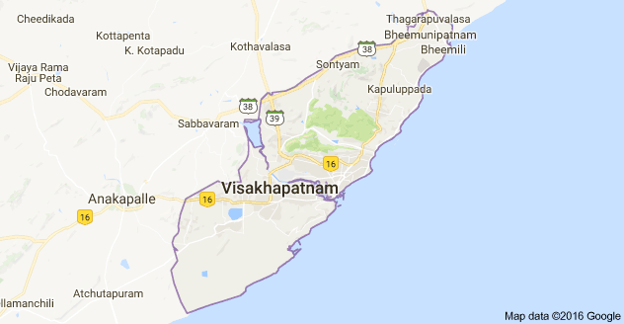

**International Journal of Humanities and Social Science Research**

**International Journal of Humanities and Social Science Research**

**ISSN: 2455-2070; Impact Factor: RJIF 5.22**

**www.socialresearchjournals.com**

**Volume 2; Issue 9; September 2016; Page No. 55-58**

**Socio-Economic conditions of women in construction industry- A study in Visakhapatnam**

**City A.P. India**

**Dr. P Jayalakshmi**

Reader in Economics, Principal Investigator, Ugc-Minor Research Project 2014-16, St. Joseph’s College For Women (A)

Visakhapatnam, Andhra Pradesh, India

**Abstract**

The present study is aimed to explore socio-economic problems of Visakhapatnam women workers at construction sites in working environment and to document issues like gender bias, living conditions, vulnerability and slackness, wages, their economic status by finding out their savings, loan etc. The author concentrated only on the women workers who are working in the construction sector and how they are facing problems in the work place. Majority of the women construction workers are facing lots of problems like absence of social security, low wages, gender discrimination, unhygienic conditions at work place etc. Data was collected from 160 women workers from four areas of Visakhapatnam (North, East, West, South) city. The data for this study has been collected through primary source. The primary for this study was collected with the help of the questionnaire. The secondary data was collected from the library and websites. The major findings of construction women labor facing many problems they asked government security for their jobs.

**Keywords:** Construction Industry, Unskilled workers, Social security, Environment

**Introduction**

In any developing economy in the globe, majority are employed in unorganized sector only. The employment of unorganized sector is mainly are agriculture, dairy, small scale industries, animal husbandry, fisheries, handlooms, handicrafts etc. The number of women in the unorganized sector is many times more than that in the organized sector because of their education, skills, family restrictions, lack of suitable employment opportunities etc. There are no strict laws to govern the unorganized sector in any economy. Hence, there is no full-fledged security of job or any common benefits to the employees. Among the unorganized industries, 95 percent of works are purely contract basis and seasonal one.

The construction industry is the largest employer in India and in the World. It is the big industry after agriculture sector. It is an integral part of a Country’s infrastructure and industrial development. The contribution of the construction industry to the economic and social life of the country is significant. Along with the construction industry creates substantial employment and also develops to other sectors through backward and forward linkages. It is essential therefore, that this vital activity encouraged and helps for the healthy growth of the economy. After separation of Andhra Pradesh, the sector also recorded the highest growth rate in generation of jobs in the last two years, doubling its share in total employment in the state.

The study concentrated on the socio-economic conditions of women workers engaged in construction works in Visakhapatnam city. In order to study the socio economic conditions of women workers engaged in construction works.

**Table 1:** Age wise Structure of Women construction workers

|  |  |  |
| --- | --- | --- |
| **Workers Age group** | **No of Workers** | **Percentage** |
| Below 20 | 29 | 18.13 |
| 21-30 | 38 | 23.75 |
| 31-40 | 54 | 33.75 |
| 41-50 | 22 | 13.75 |
| 51-and above | 17 | 10.62 |
| Total | 160 | 100.00 |

***Source*:**Primary data

Table-1 depicts the age group of women construction workers in Visakhapatnam city. Construction work is painful in nature which requires hard labor and physical strength in which age plays an important role. The highest proportion of women construction workers, i.e. more than three forth of them has recorded in 21-40 years age group. After this Age group the proportion of Women Construction workers in Age group of 41-50, 51 and above have been recorded 13.75 percent and 10.62 percent respectively. While only 18.13 percent construction workers were below 20 years age. It indicates that the women workers of the construction industry in the young and productive age groups.

|  |  |  |  |  |  |  |  |
| --- | --- | --- | --- | --- | --- | --- | --- |
|  |  |  |  |  |  |  |  |

**International Journal of Humanities and Social Science Research**

**Table 2:** Marital Status of the selected women worker

|  |  |  |  |  |  |  |  |
| --- | --- | --- | --- | --- | --- | --- | --- |
| **Women construction** |  | **Marital Status** | |  | **Unmarried** | **Total Percentage (%)** |  |
| **workers** | **Married (Single)** | **Widow** | **Divorced** | **Married (Family)** |  |
|  |  |  |
| Number | 67 | 09 | 11 | 61 | 12 | 160 |  |
| Percentage | 41.87 | 5.63 | 6.88 | 38.12 | 7.5 | 100.00 |  |
| ***Source*:**primary data |  |  |  |  |  |  |  |

|  |  |  |  |  |  |  |  |  |
| --- | --- | --- | --- | --- | --- | --- | --- | --- |
| The marital status of women workers in construction industry | | | | in Visakhapatnam city is shown in the above table. | | | |  |
|  |  | **Table 3:** Age at Marriage of sampled women | | | |  |  |  |
|  |  |  |  |  |  |  |  |  |
|  | **Women construction workers** | **Age at Marriage (year)** | | | | **Unmarried** | **Total Percentage** |  |
|  | **Below- 16** | **16-18** | **19-21** | **Above 21** |  |
|  |  |  |  |  |
|  | Number | 14 | 48 | 82 | 04 | 12 | 160 |  |
|  | Percentage | 8.75 | 30.00 | 51.25 | 2.50 | 7.50 | 100.00 |  |
|  |  |  |  |  |  |  |  |  |
|  | ***Source*:**primary data |  |  |  |  |  |  |  |

The above table shows that the age at marriage of women workers engaged in sampled construction sites of Visakhapatnam city. Table-3 out of 160 sampled women workers, 12 are unmarried. So, the rest of 148 women workers are either married or widow or divorced. It can be said that, at one point of time 148 workers were married. Out

of 148 women workers, 14 (8.75%) percent got married within the age group of below 16 years. 48 (30.00%), 82 (51.25%) and 04 (2.50%) got married in the age group of 16-18 years, 18-21 years and above 21 years respectively as depicted in table-5.

**Table 4:** Number of Children of each women worker amongst the sample

|  |  |  |  |  |  |  |  |
| --- | --- | --- | --- | --- | --- | --- | --- |
| **Women workers** |  | **Number of Children** | |  | **Unmarried** | **Total** |  |
|  | **1 2 3 4 & Above** | |  | **Women workers** |  |
|  |  |  |  |  |
| Number | 17 | 74 | 36 | 21 | 12 | 160 |  |
| Percentage (%) | 10.625 | 46.25 | 22.5 | 13.125 | 7.5 | 100.00 |  |

***Source*:**Primary data

The above table depicts that 46 percent of women workers in the study have 2 children each, 10 percent, 23 percent and 13 percent of the women labor have one, three and four and more

children each. Total Number of women workers is 160. Here 12 women workers have been taken into consideration as they were unmarried.

**Table 5:** Family sizes of the sampled Women workers in Visakhapatnam city

|  |  |  |  |  |  |  |  |  |
| --- | --- | --- | --- | --- | --- | --- | --- | --- |
| **Women workers** | **Number of Family members** | | | | |  | **Total** |  |
|  | **1-3 3-5 5-8 8 and above** | | | |  |  |
|  |  |  |  |  |
| Number | 43 |  | 87 | 26 |  | 04 | 160 |  |
| Percentage (%) | 26.88 |  | 54.38 | 16.25 |  | 2.5 | 100.00 |  |

***Source*:**Primary data

The above Table-5 shows that the family size of the women workers in the construction industry of Visakhapatnam city, the analysis of the above table reveals that 54 percent of the women workers of the selected sample in the city have the family size ranging from 3 to 5 each. 27 percent of the

women workers have the family members ranging from 1-3. 16 percent of women have the family size ranging from 5-8 members each. There are only 4 families have more than 8 members each.

**Table 6:** Educational Levels of the women workers in the construction industry in Visakhapatnam city is displayed

|  |  |  |  |  |  |  |  |
| --- | --- | --- | --- | --- | --- | --- | --- |
| **Women workers** |  |  | **Levels of Education** | |  | **Total** |  |
| **Illiterate** | **Just Literate** | **Class I-V** | **Class VI-VII** | **Class VIII & more** |  |
|  |  |  |
| Number | 41 | 58 | 32 | 24 | 05 | 160 |  |
| Percentage (%) | 25.625 | 36.25 | 20.00 | 15.00 | 3.125 | 100.00 |  |

***Source*:**Primary data

The above table -6 depicts that, the educational levels of the women workers in construction industry in Visakhapatnam city, out of 160 sample of the research study, 26 percent of the women workers engaged in the construction works in the

city under the category of illiterate. Only 36 percent of the women workers are just literate. 20%, 15% and 3% of the women workers have studied up to class I-IV, Class VI-VII and Class VIII and more respectively.

**International Journal of Humanities and Social Science Research**

**Table 7:** Shows that the Educational levels of children of the women workers in construction works in the Visakhapatnam city.

|  |  |  |  |  |  |  |  |
| --- | --- | --- | --- | --- | --- | --- | --- |
| **Women workers** |  | **Level of Education of Children** | | |  | **Total** |  |
| **No Education** | **Class I-II** | **Class II-IV** | **Class IV-VII** | **VII and above** |  |
|  |  |  |
| Number | 24 | 48 | 40 | 20 | 16 | 148 |  |
| Percentage (%) | 16.22 | 32.43 | 27.03 | 13.51 | 10.81 | 100.00 |  |

***Source*:**primary data

The education levels of children of 16 percent of women workers do not have any education at all as depicted in the above table-7. The Children of 32 percent of women workers

have attained formal education (Class I-II) and the Children of Class II-IV. And only 10.81 percent are educated VII and more.

**Table 8:** Migration among the sampled construction women workers in Visakhapatnam city

|  |  |  |  |  |  |  |  |
| --- | --- | --- | --- | --- | --- | --- | --- |
| **Women workers** |  | **Migration** |  |  | **Local** | **Total** |  |
| **Same district** | **Other district** | **Other state** | **total** |  |
|  |  |  |  |
| Number | 22 | 77 | 43 | 142 | 18 | 160 |  |
| percentage | 13.75 | 48.125 | 26.875 | 88.75 | 11.75 | 100.00 |  |

***Source*:**Primary data

The above table-8 shows that out of 160 women workers, 142 women workers are migrate and only 18 were local residents. Due to lack of agricultural and traditional works these people are migrate and join in the construction works. So

construction industry is the second largest employer in the country. Some of them are coming from other states like Orissa, West Bengal Tamil Nadu etc.

**Table 9:** Women workers with regard to the earning members of their families.

|  |  |  |  |  |  |  |  |
| --- | --- | --- | --- | --- | --- | --- | --- |
| **Women workers** | **Earning members of the respondents family in the study** | | | | | **Total** |  |
| **1** | **2** | **3** | **4** | **5 & above** |  |
|  |  |  |
| Number | 29 | 74 | 44 | 09 | 04 | 160 |  |
| Percentage | 18.13 | 46.25 | 27.50 | 5.62 | 2.50 | 100.00 |  |

***Source*:**primary data

The above table depicts that out of 160 sampled women construction workers, 46 percent and 27 percent families there are 2 and 3 working members respectively per family. 18 percent of families of women workers have 1 earning

member, and 5 percent of families have 4 earning members. Only 2.5 percent of families have 5 and above earning members.

**Table 10:** Monthly income of the women construction workers in the study

|  |  |  |
| --- | --- | --- |
| **Monthly income categories (Rs)** | **No of workers** | **Percentage of Labors** |
| Below-5000 | 11 | 6.87 |
| 5000-7000 | 25 | 15.63 |
| 7000-9000 | 42 | 26.25 |
| 9000-11000 | 73 | 45.63 |
| Above-11000 | 09 | 5.62 |
| Total | 160 | 100.00 |
| ***Source*:**Primary data |  |  |

From the above table it comes to our notice that the monthly income of 45 percent of the sampled women workers attached to the construction industry under study lie between Rs 9000 to 11000. Only 26 percent of the interviewed women workers

earn monthly between Rs. 7000 to Rs. 9000/-. Recently the Labor Laws are protecting the women wages. More than 70 percent of women are getting the same wage along with men.

**Table 11:** Sources of Family Income of the construction women workers

|  |  |  |  |  |  |  |  |  |
| --- | --- | --- | --- | --- | --- | --- | --- | --- |
| **Women workers** |  |  | **Sources of Family income** | |  |  | **Total** |  |
| **Agriculture works** | **Daily labor** | **Small business** | **Servant maid** | **Schools** | **Other type of work** |  |
|  |  |  |
| Number | 07 | 44 | 37 | 34 | 26 | 12 | 160 |  |
| Percentage | 4.37 | 27.50 | 23.13 | 21.25 | 16.25 | 7.50 | 100.00 |  |

***Source*:**Primary data

The above table depicts that Daily labor and small business are the major sources of livelihood of the family members of the women workers in the construction industry. The next source of family income is servant maid job (21.25). The family members are engaged in the above said activities to maintain the family for livelihood. They are to depend on

other activities, as the construction works are not available times. So, all the workers cannot depend solely on the work of construction industry, round the year. During not availability of construction works, they engage themselves either as servant maid, daily labor, small business etc.

**International Journal of Humanities and Social Science Research**

**Table 12:** Indebtedness of construction women workers in Visakhapatnam city

|  |  |  |  |  |  |  |  |
| --- | --- | --- | --- | --- | --- | --- | --- |
| **Women workers** |  |  | **Indebted to** |  |  | **Total** |  |
| **Contractor** | **Co-Workers** | **Relatives & Friends** | **Money lenders** | **No indebtedness** |  |
|  |  |  |
| Number | 69 | 47 | 22 | 15 | 07 | 160 |  |
| Percent | 43.13 | 29.37 | 13.75 | 9.37 | 4.38 | 100.00 |  |

***Source*:**Primary data

The above table-12 depicts that 43 percent of the women workers are indebted to the work contractors. About 29 percent of the women workers are indebted to co-workers. Only 13 percent, 9 percent are indebted to relatives and money lenders respectively.

A meager percent (4%) of women workers are not indebted to anybody. The main reason for indebtedness to women construction workers is to perform family traditions and customs in the society

**Table 13:** Types of demands of women workers in construction industry

|  |  |  |  |  |  |  |  |  |  |  |
| --- | --- | --- | --- | --- | --- | --- | --- | --- | --- | --- |
| **Women** |  |  |  | **Types of demands** | |  |  |  |  |  |
| **wage** | **Paid** | **Safety&** | **Sanitation** | **Medical** | **Rest** | **Precautionary** | **Baby care** | **Total** |  |
| **workers** |  |
| **increase** | **holiday** | **security** | **facilities** | **facility** | **room** | **equipment** | **facility** |  |  |
|  |  |  |
| Number | 54 | 27 | 18 | 31 | 10 | 12 | 05 | 03 | 160 |  |
| Percentage | 33.75 | 16.88 | 11.25 | 19.37 | 6.25 | 7.5 | 3.12 | 1.88 | 100.0 |  |

***Source*:**primary data

The above table-13 clearly indicates that 34 percent of the total sampled women workers demanded for increase in wages as the hike in wages may help them maintain their families. 17 percent of women are demand paid holidays in some occasions (pongal, dasara). Nearly 19 percent of women are demanded sanitation facilities for health protection purpose. 11 percent are demanding safety and security measures at work place and 3 percent are asking precautionary equipment like Helmet, hand gloves shoes and season cloths etc. 1.88 percent of women demanding baby care facilities at work site because in the nuclear families, no elders at home to look after their babies.

**Conclusion**

Construction industry is an ongoing industry with the increase in the population there is an increase in the demands of the construction works proportionately in the form of houses, malls offices, apartments etc. The construction industry women workers are facing some socio-economic problems in the Visakhapatnam city. The government and real estate leaders must try and understand the situation of the women construction workers. The overall analysis of the study reveals that the construction workers are one of the poorest sections of the society, living in poverty. For better living of construction workers they should be added in government sector.

**Acknowledgement**

I am thankful to The Secretary, the staff members of UGC, SERO, Hyderabad, Andhra Pradesh, for funding this Minor Research Project.

**References**

1. Arup Mitra, Swapna Mukhopadhay. Female Labor absorption in construction sector, Economic and Political weekly. 1980-1989; 24(10).
2. Baruah B. Gender and globalization; opportunities and constraints faced by women in the construction industry in India. Labour Stud J. 2008; 35:1-24. Available from: http://lsj.sagepub.com.
3. Construction Industry Development Council. Ahmedabad, India. First international seminar on skill up gradation of women workers in a globalizing construction industry, 2003.
4. Directorate of Economic Statistics, Government of Andhra Pradesh.
5. Hari Priya K. A study of Construction industry in Haryana Publication New Delhi, 2007-08.
6. www.reuters.com/article/2015/01/12/us-india-women-construction-idUSKBN0KL00920150112
7. Planning Commission of India. Labour Laws and Other Labour Regulations, (PDF). The Government of India, 2007.
8. www.indianmirror.com/indian-industries/construction. html
9. www.sokanu.com/careers/construction-worker/
10. indiatogether.org/law-and-welfare-benefits-for-construction-workers-human-rights
11. Ranade SN. Women Construction workers: reports of two surveys, Bombay Allied Publishers, 1975.
12. Unorganized Labour. Ministry of Labour, Government of India, 2009.
13. Jacob Tomy. The Unorganized Sector in India, 2011. www.Fedina.Org/777/2011/10/Unorganised-Sector-In-India1.DocOn 22/01/2014.
14. Government of India. Problems of Unorganized Sector Workers.Ministry of Labour and Employment, New Delhi, 2008;17 18.
15. Sahoo Sarbeswara. National workshop on safety, health and welfare measure for construction workers. Mahatma Gandhi Labour institute. Website: www.mgliahd.org.
16. Socio-Economic Status of Construction Workers in Guru Ghasidas University. A Pilot Study by Prof. Pratibha J. Mishra.
17. Socio-economic status of workers of building construction industry: Guddi Tiwary, PK Gangopadhyay, S Biswas, K Nayak, MK Chatterjee, D Chakraborty, S Mukherjee.

**ANNUXURE-III Photos of the Study sources.**

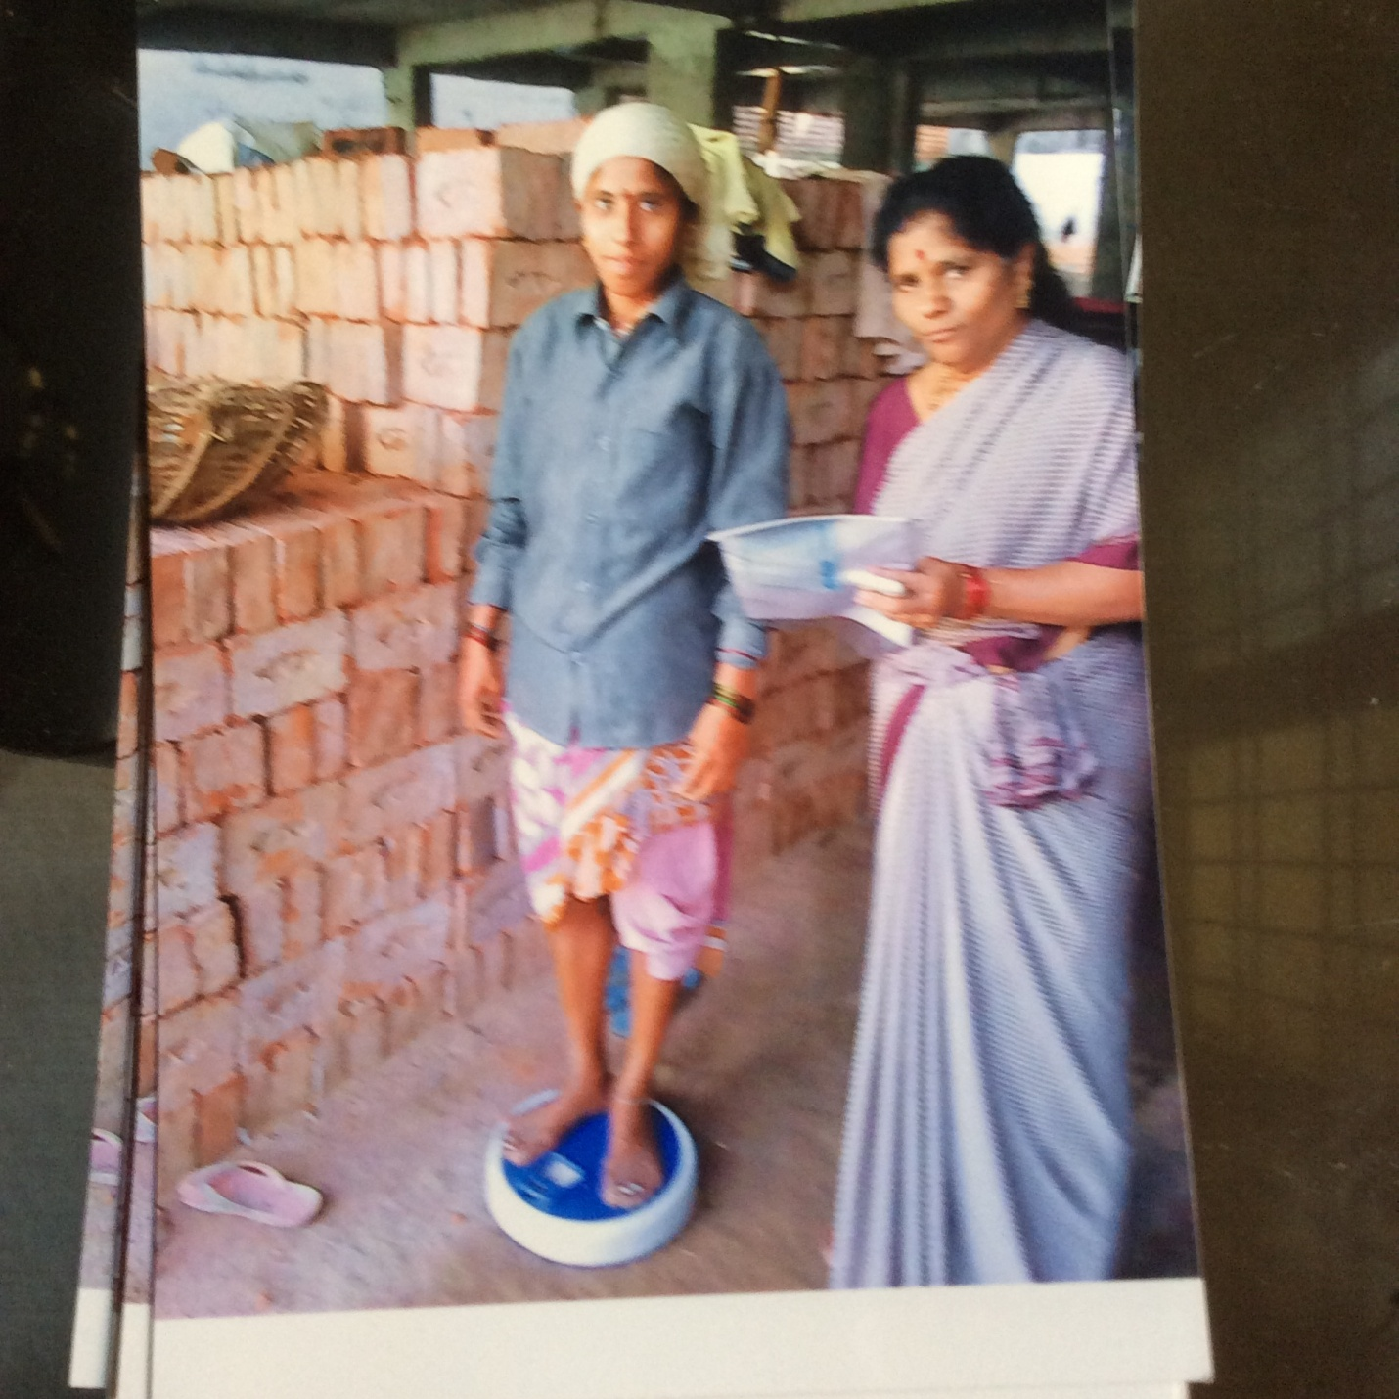

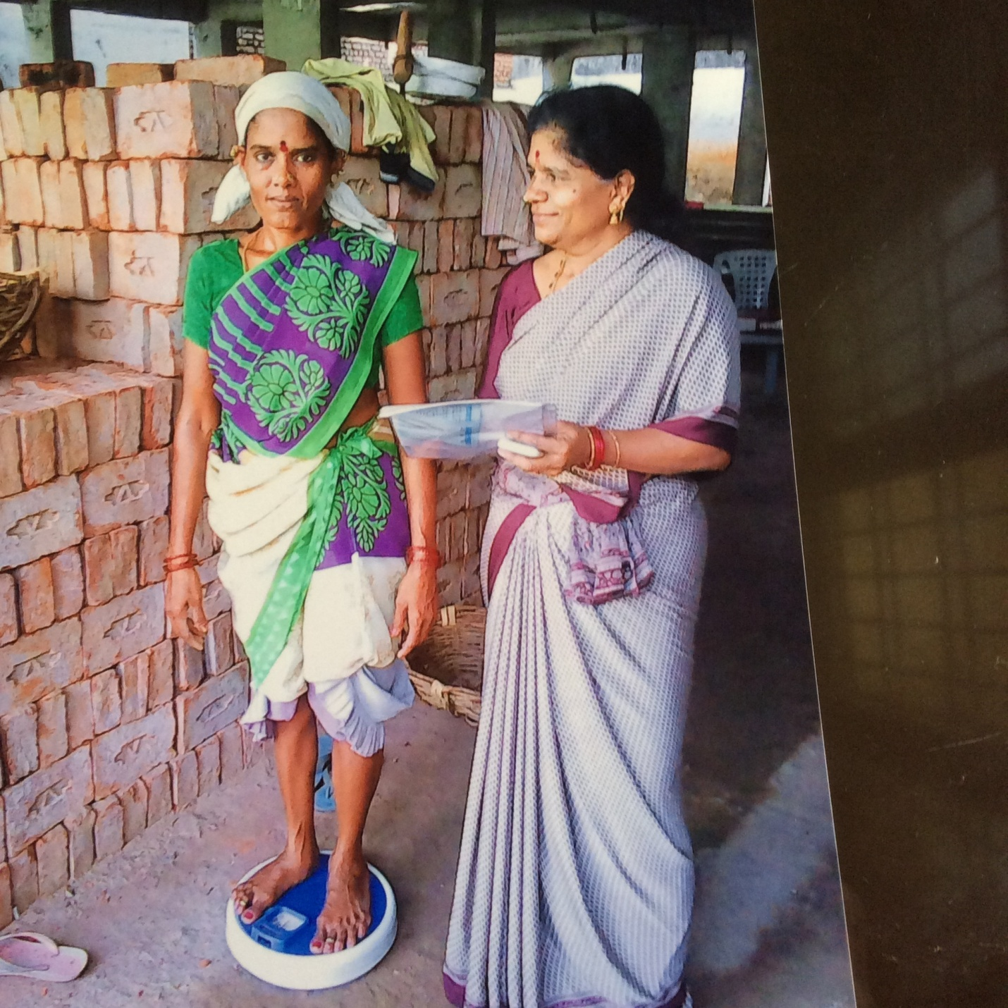

Figure Taking Weight of the respondents at work site

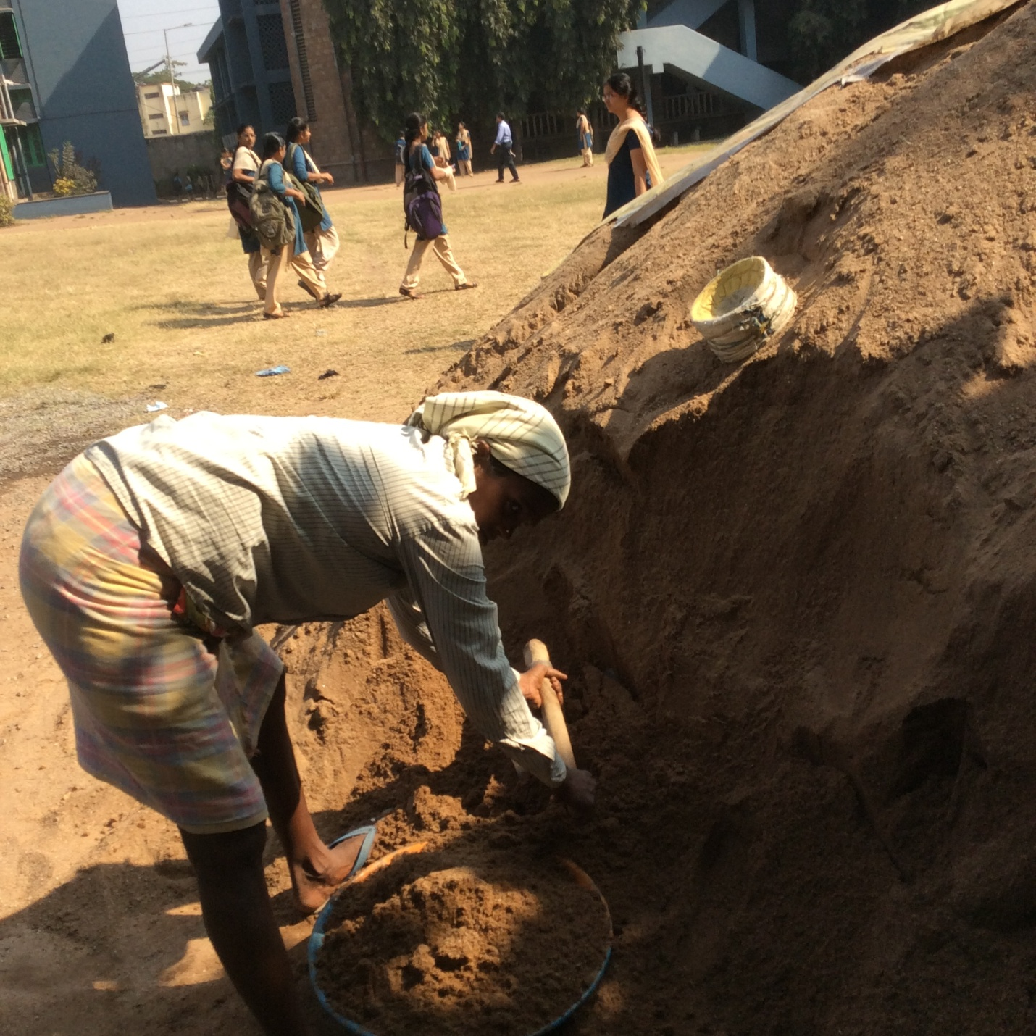

Figure Height measurement to respondents at work site

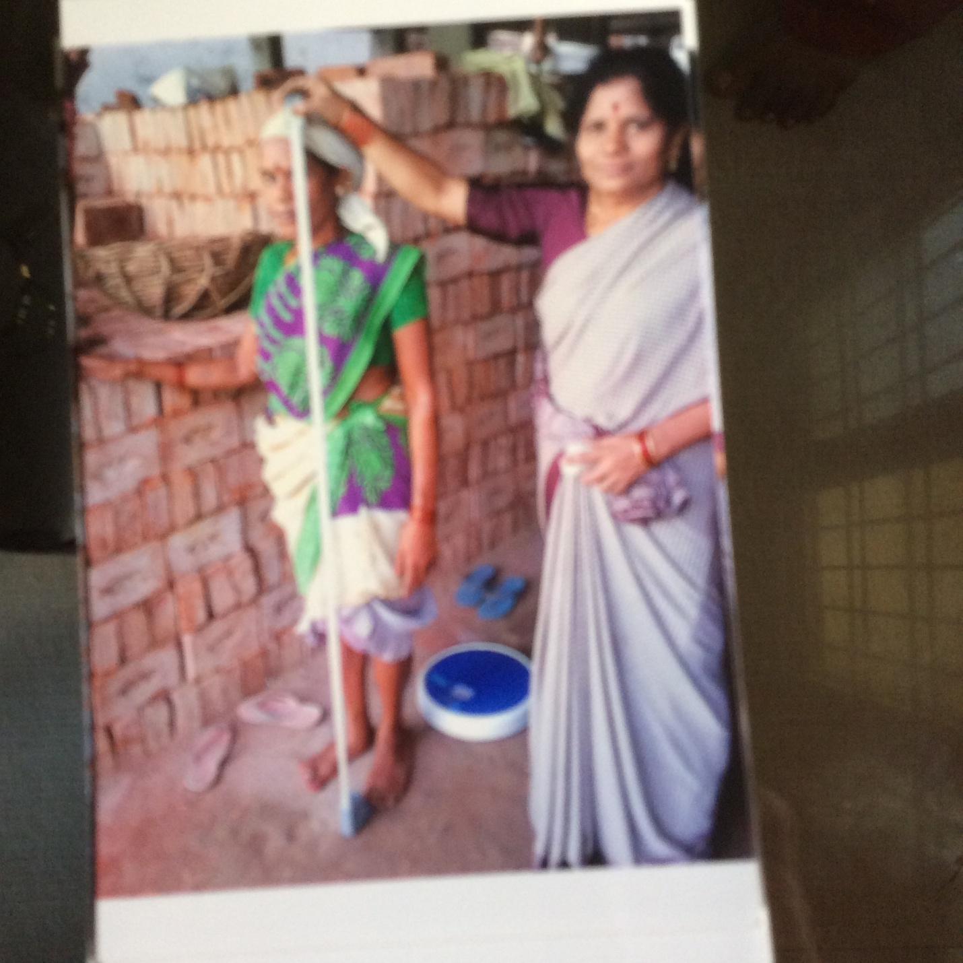

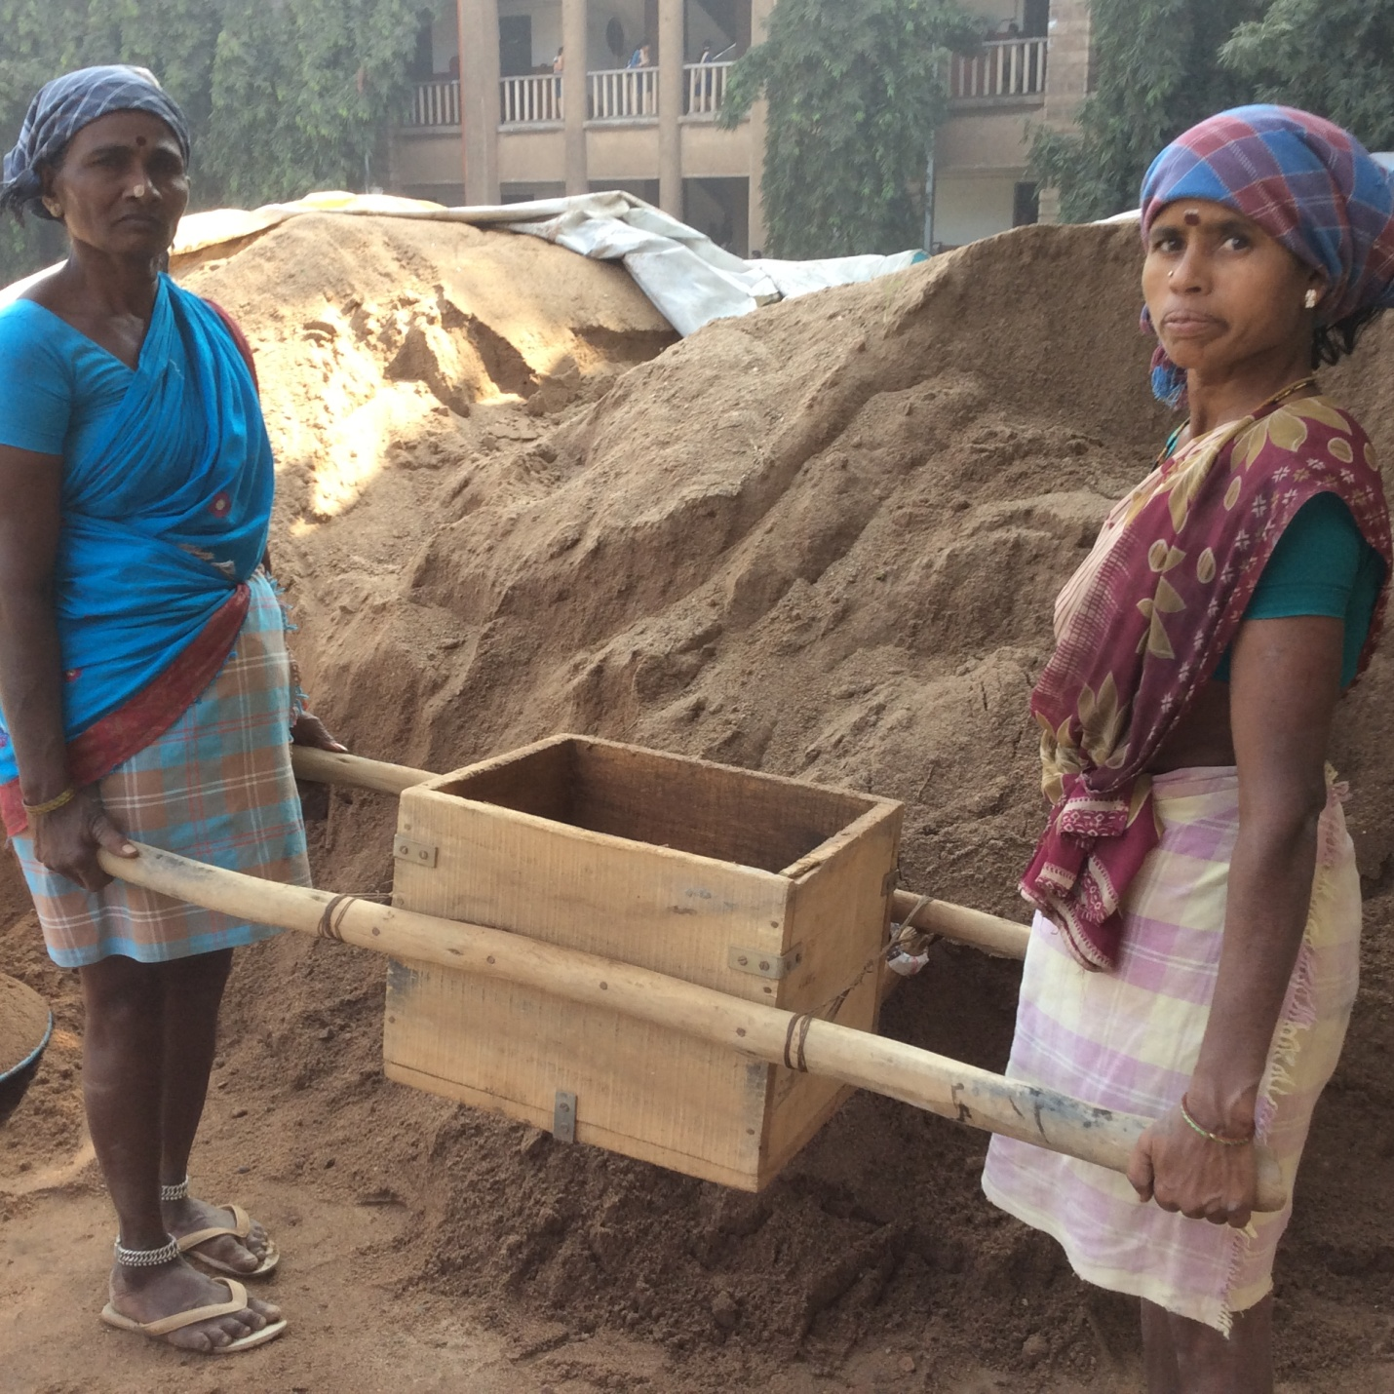

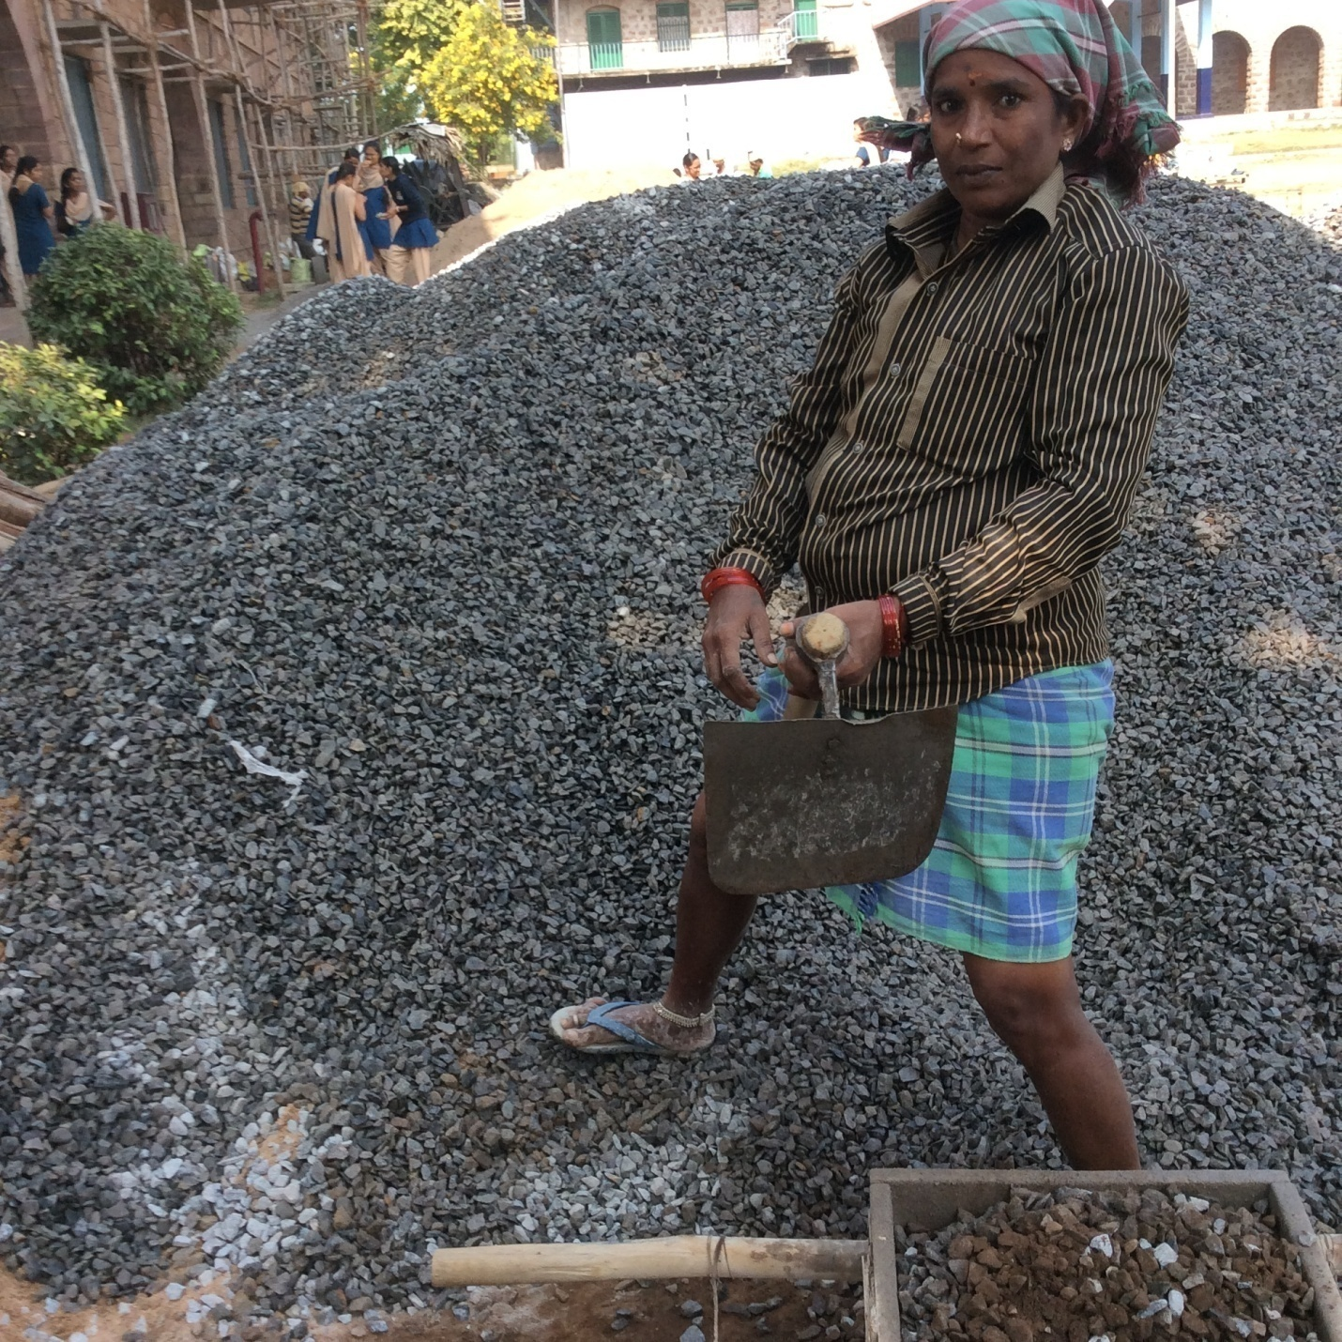

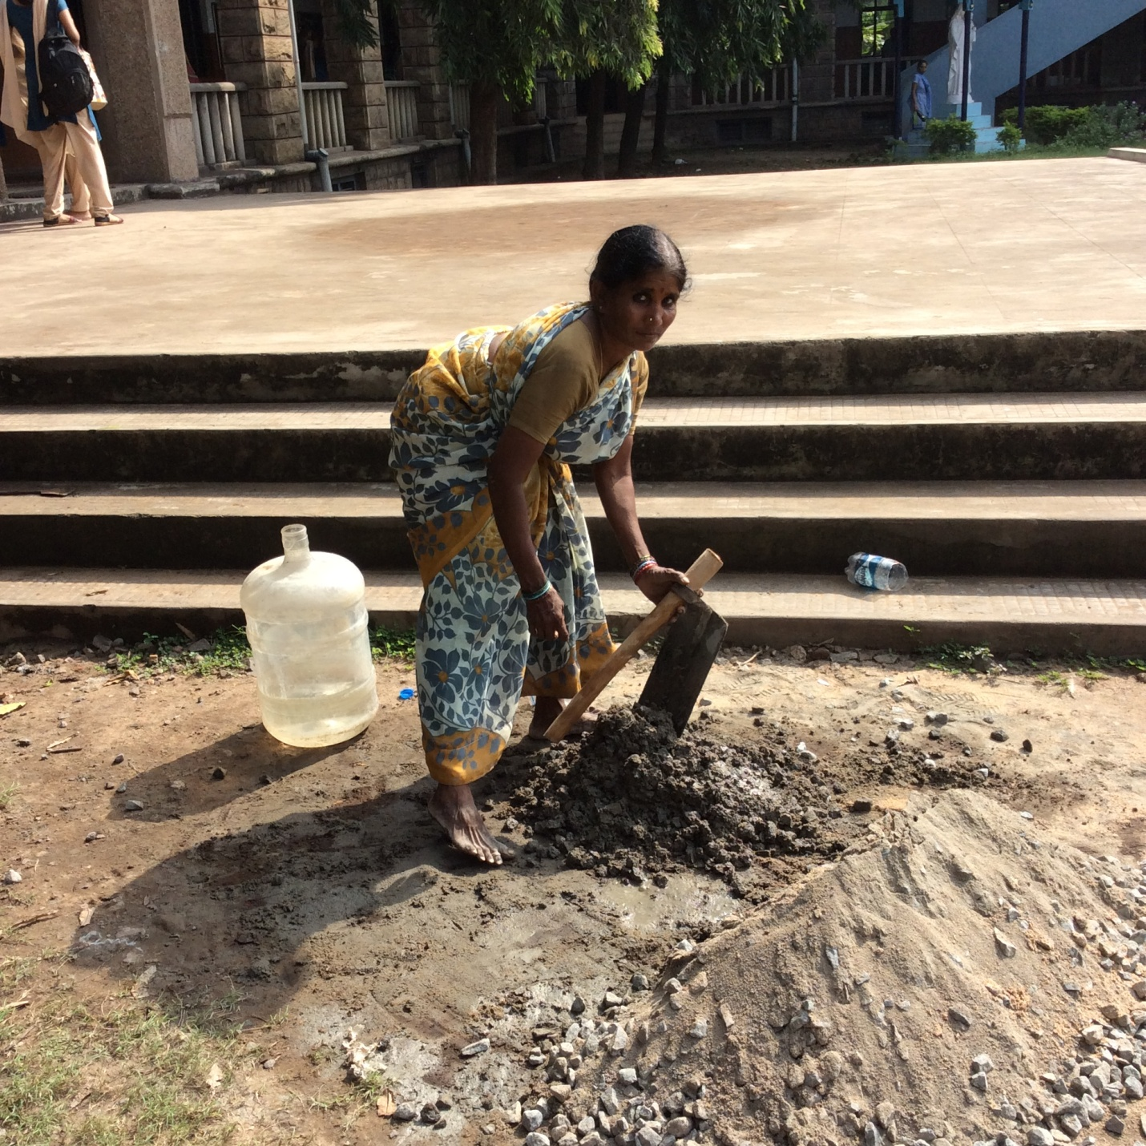

1.